# **Classification**

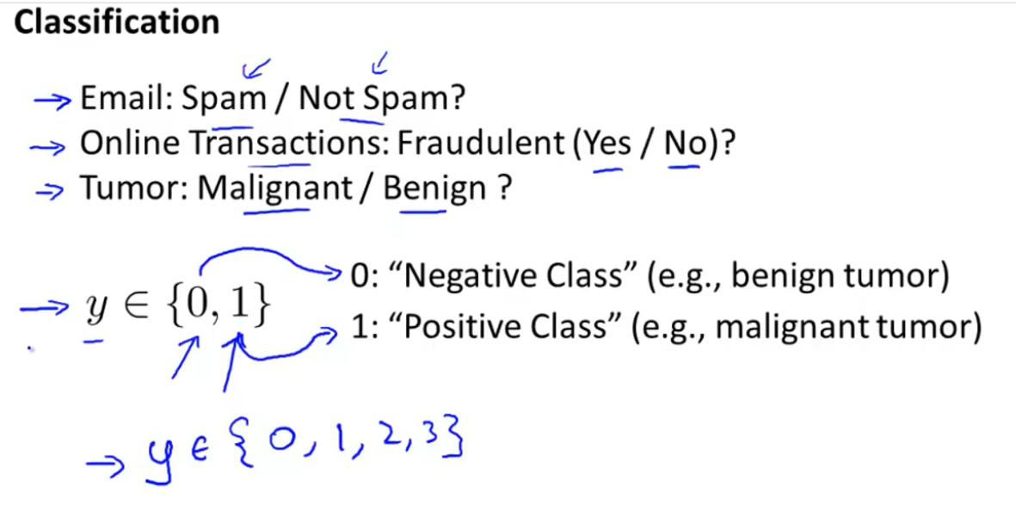



Binary classification problem Multiclass classification problem

# **Why linear regression is not suitable for classification ???**

Is it good to apply Linear Regression to the classification problem?????

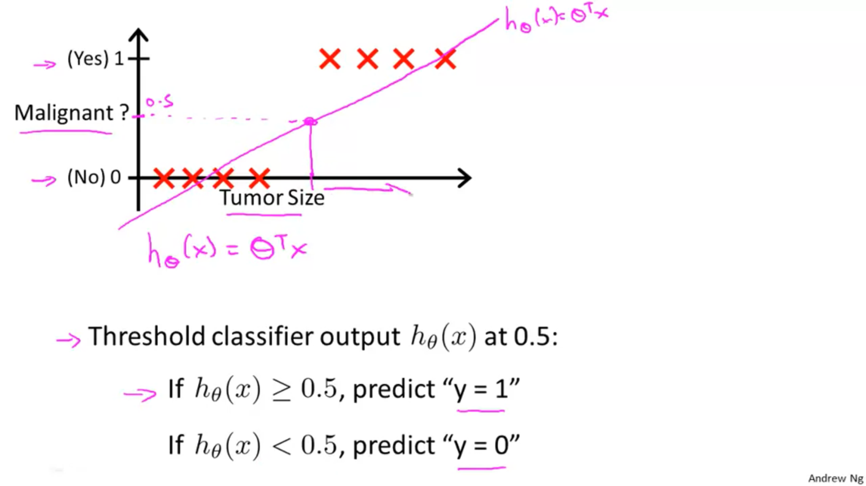



It looks like Linear Regression line is somewhat meaningful in-doing, lets see

After adding the extra point, if I run the linear regression and line shifts according to that extra point.

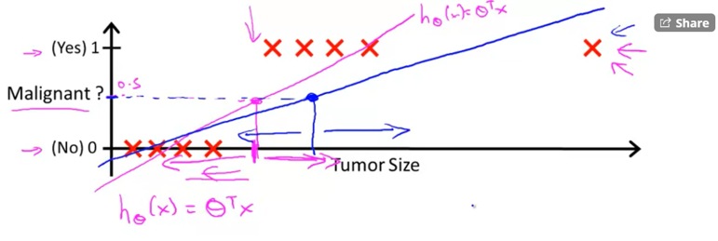Before adding the new point the existing points were +ve and after adding that new point the existing points were -ve.   
So from here it is clear that fitting the regression line and predicting the classification problem is not good choice.



# **What will happen if we apply linear regression for classification problem ??**

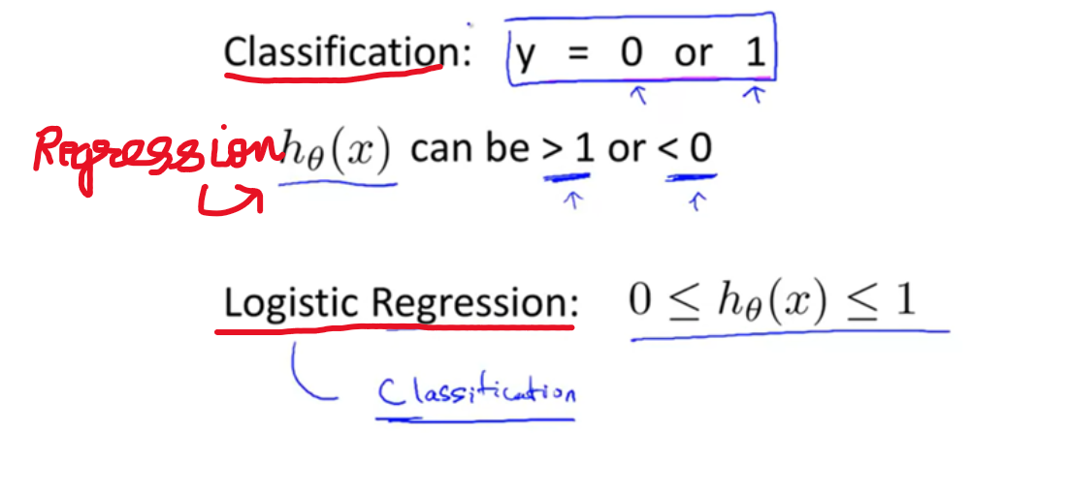

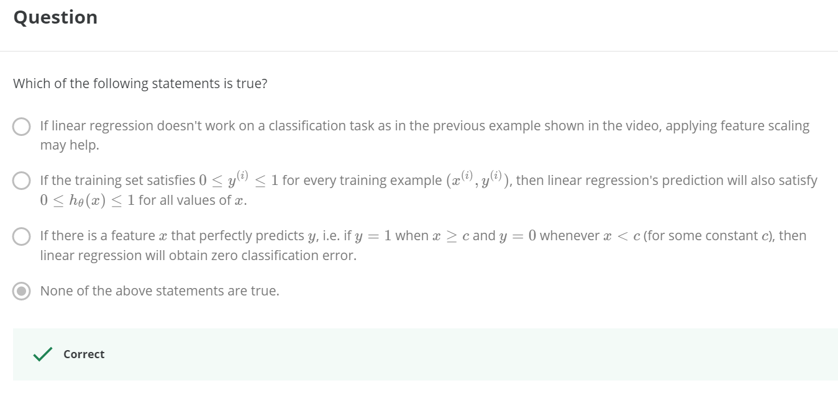

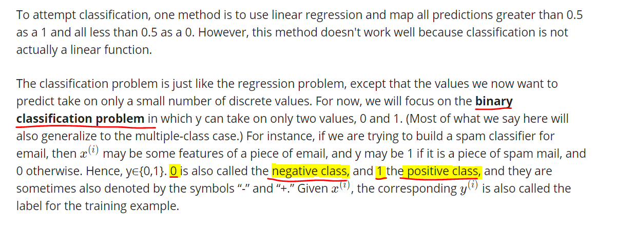

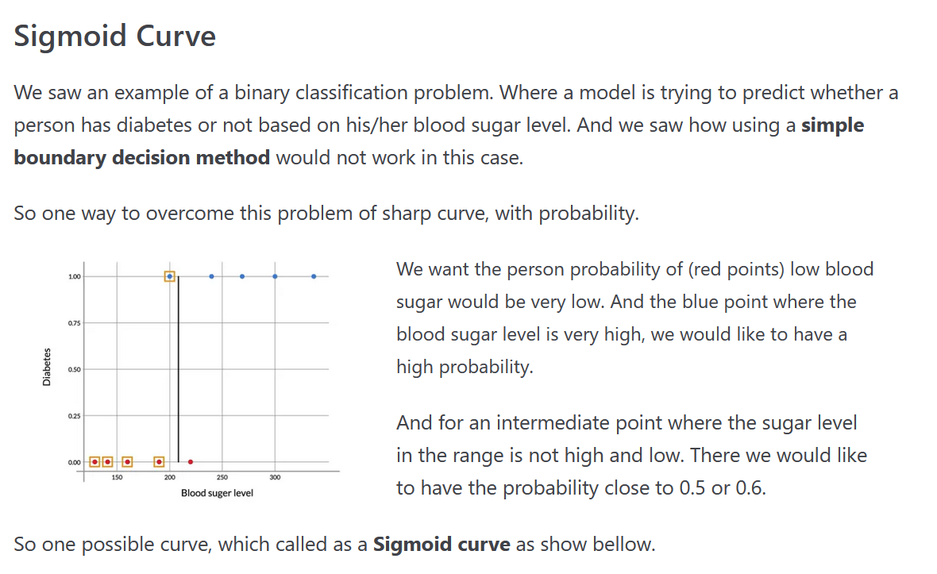

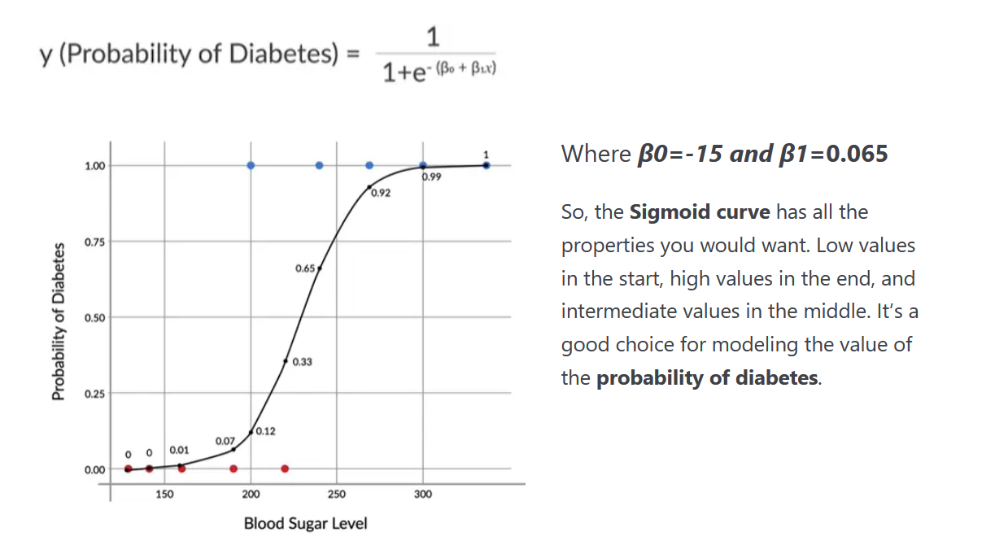



In-order to perceive this condition, we are using sigmoid function instead of fitting into a straight line.

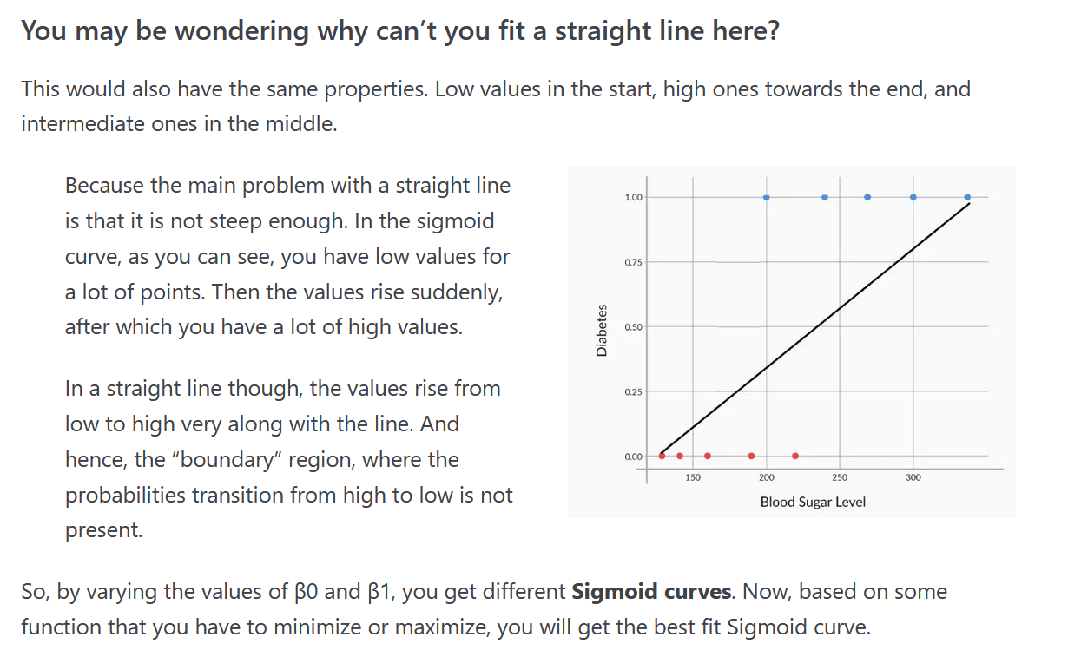

And also the value of the hypothesis will be >1 and <0 ir-respective of the input which violates the rule of Probability.

# **Hypothesis Representation**

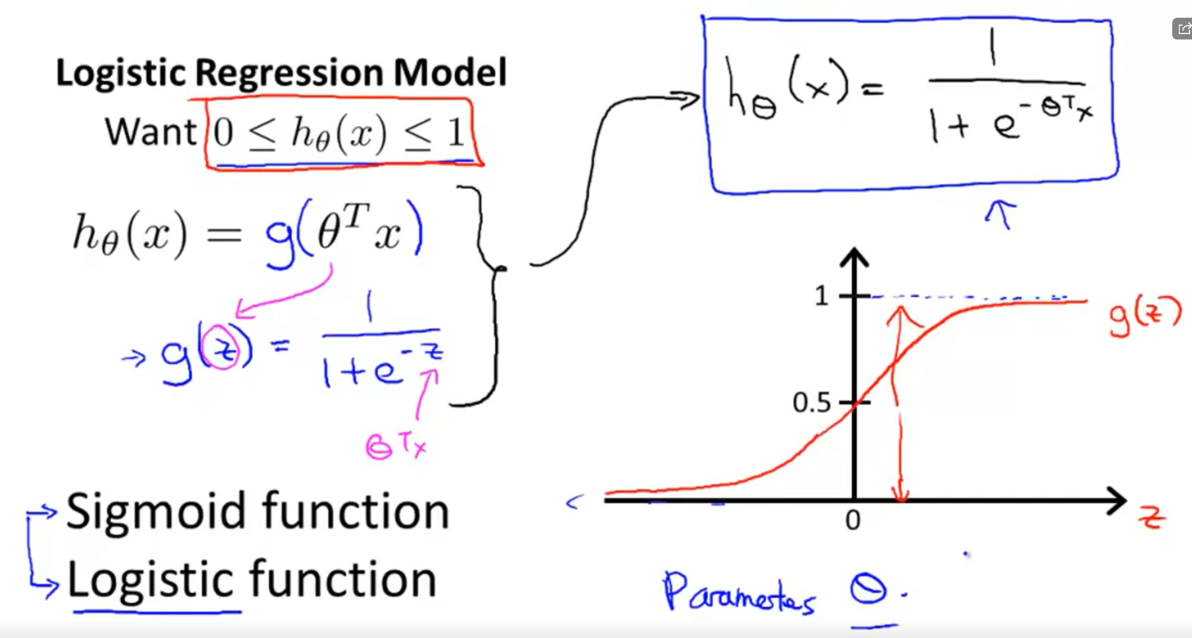



As z goes to -inf, g(z) approaches to zero.  
As z goes to +inf, g(z) approaches to one.

# **Interpretation of Hypothesis Output**

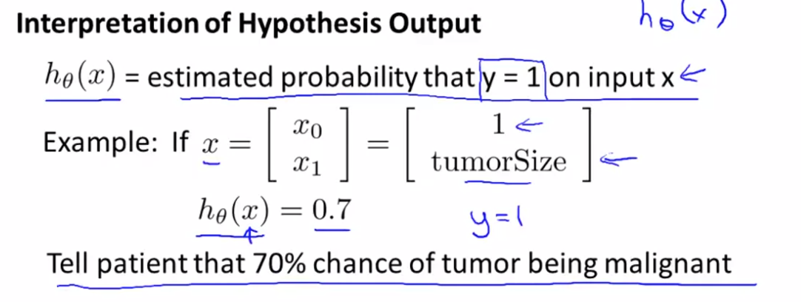

* Gives an output, and the estimated probability must be 1 on the input x.



For the patient with feature x, the P(y=1) is 0.7 (or)  
Patient have 70% chance of tumor being malignant.

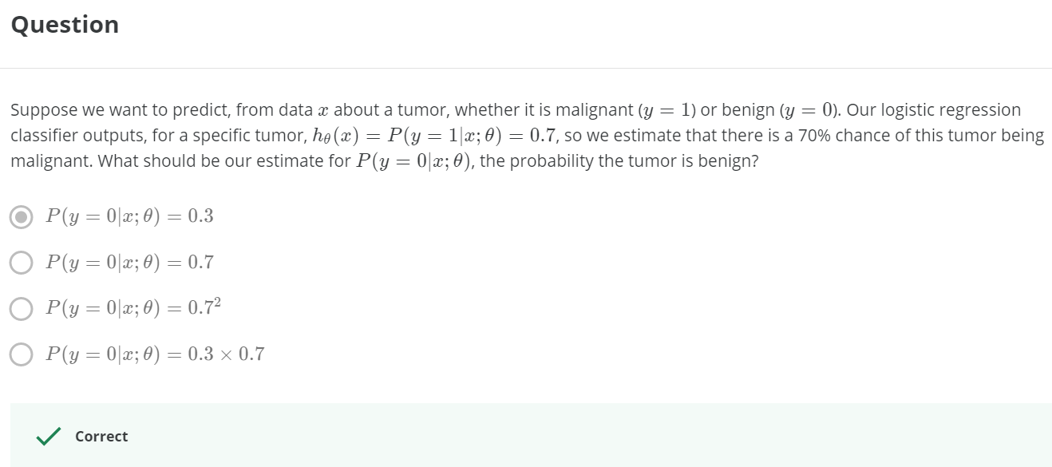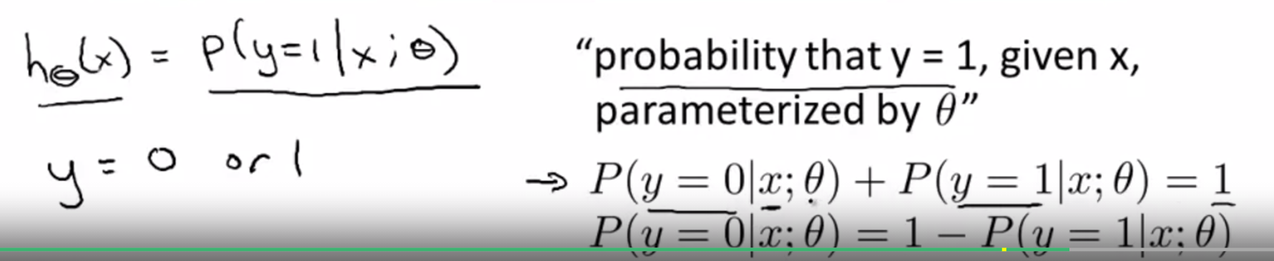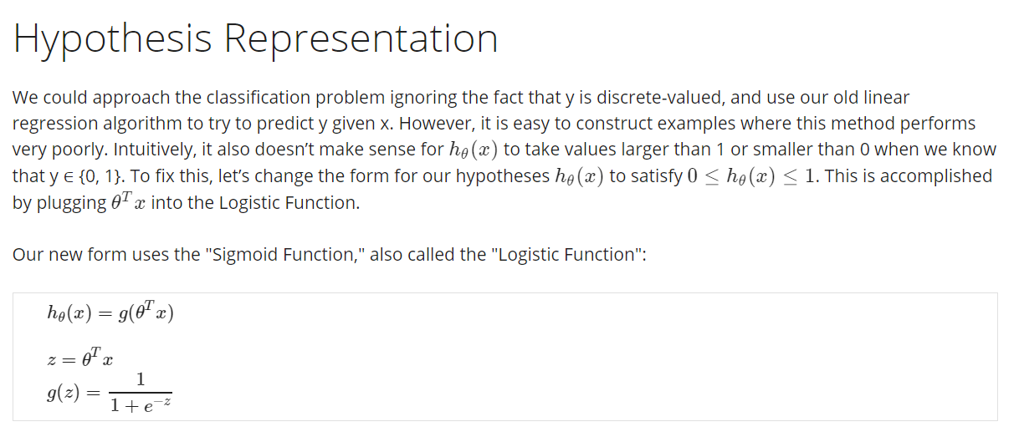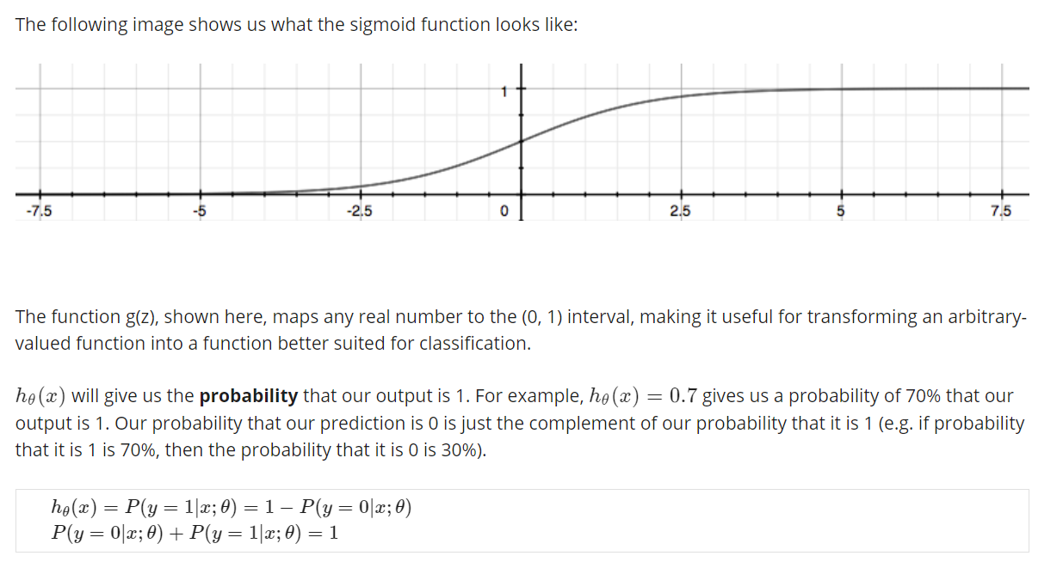

## **Decision Boundary**

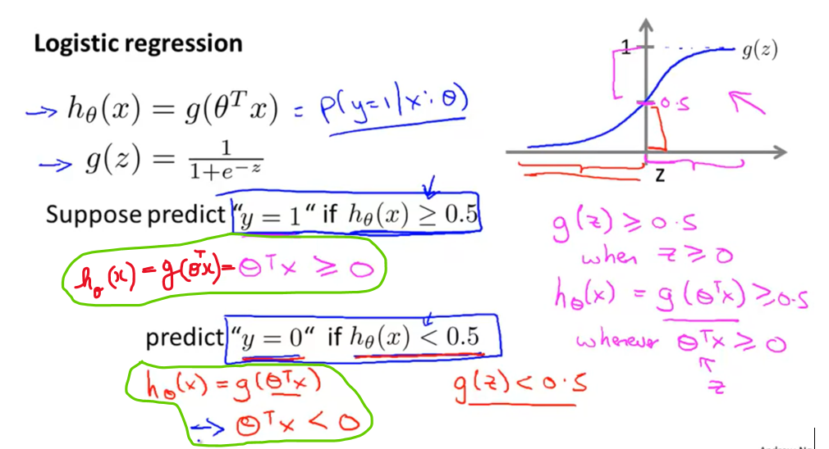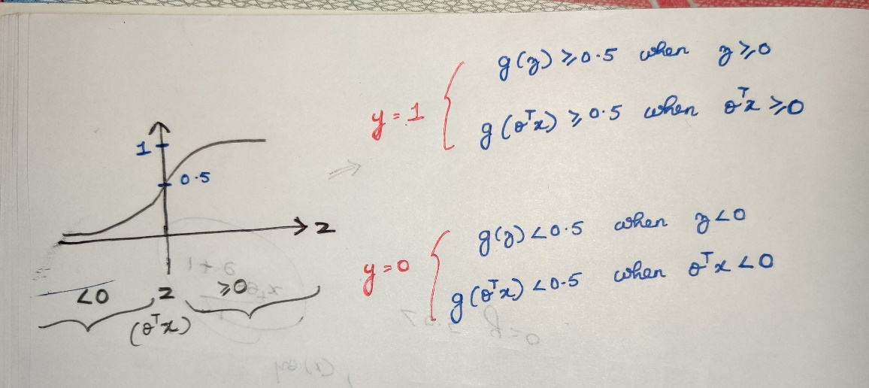

When = 0.5, the probability is either +ve/-ve . But we consider =0.5 as a +ve training example.  
With data-set



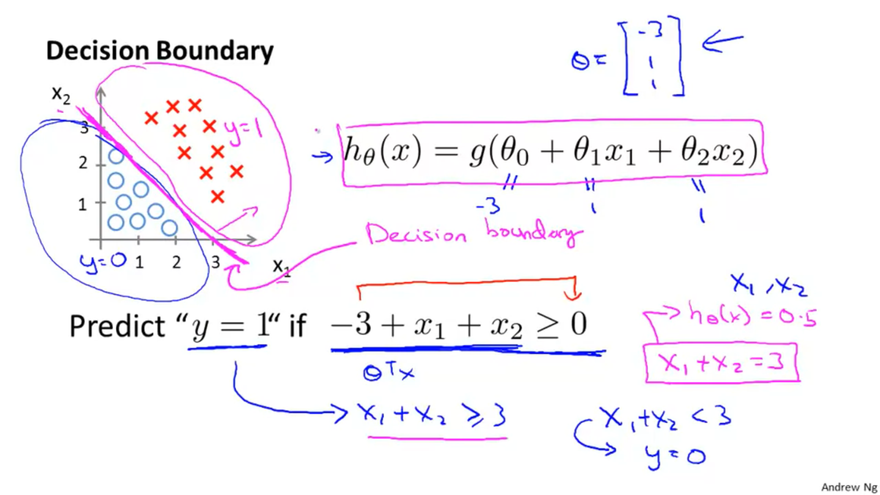

Decision boundary is the line that separates the region   
where the hypothesis predicts y=1 from the region where the hypothesis predicts y=0.

Decision boundary is the property of the hypothesis including the parameters (theta-0 , theta-1 , theta-2).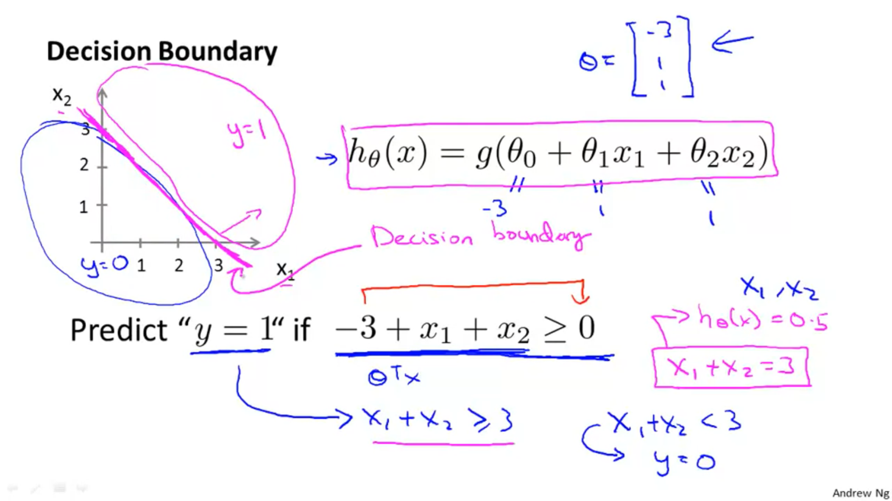  
Even we take away the data-set, this decision boundary and the region where we predict y=1 versus y=0, that is the property of the hypothesis and the parameters of the hypothesis and **not the property of the data-set.**

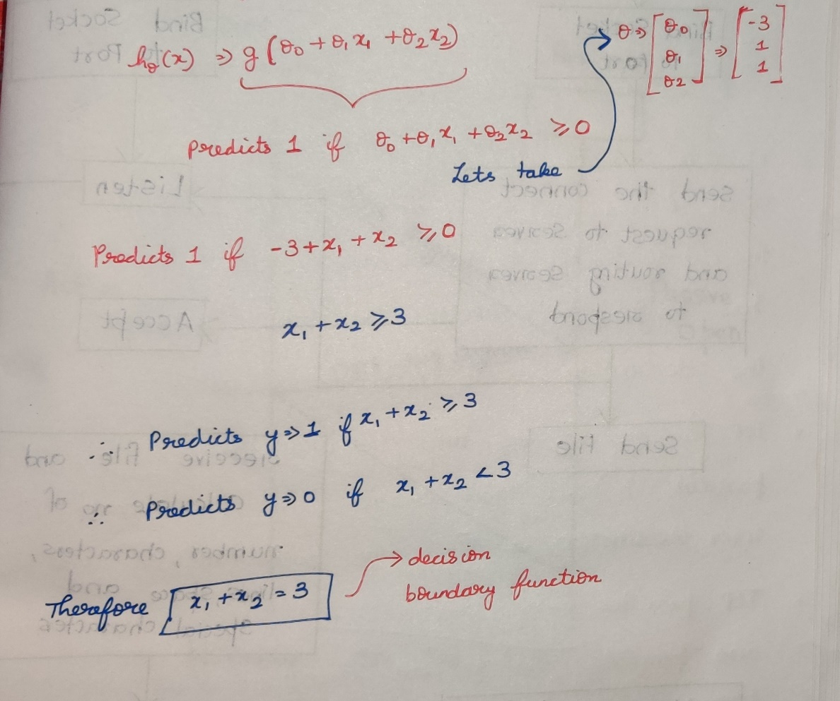

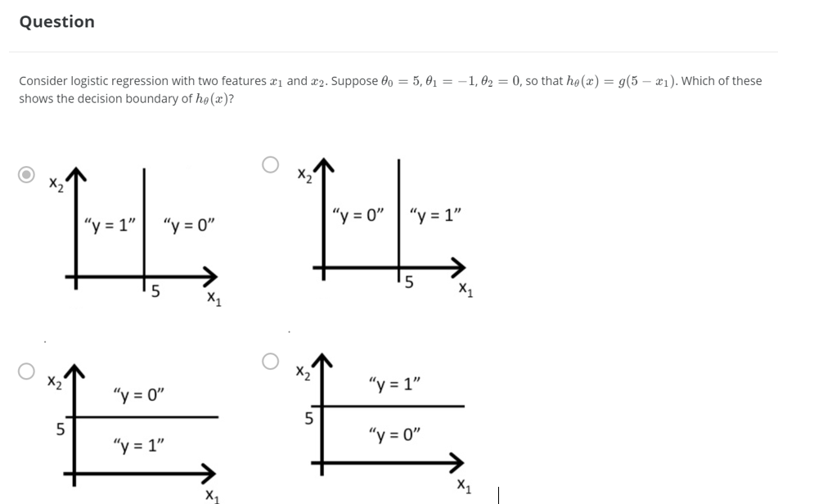

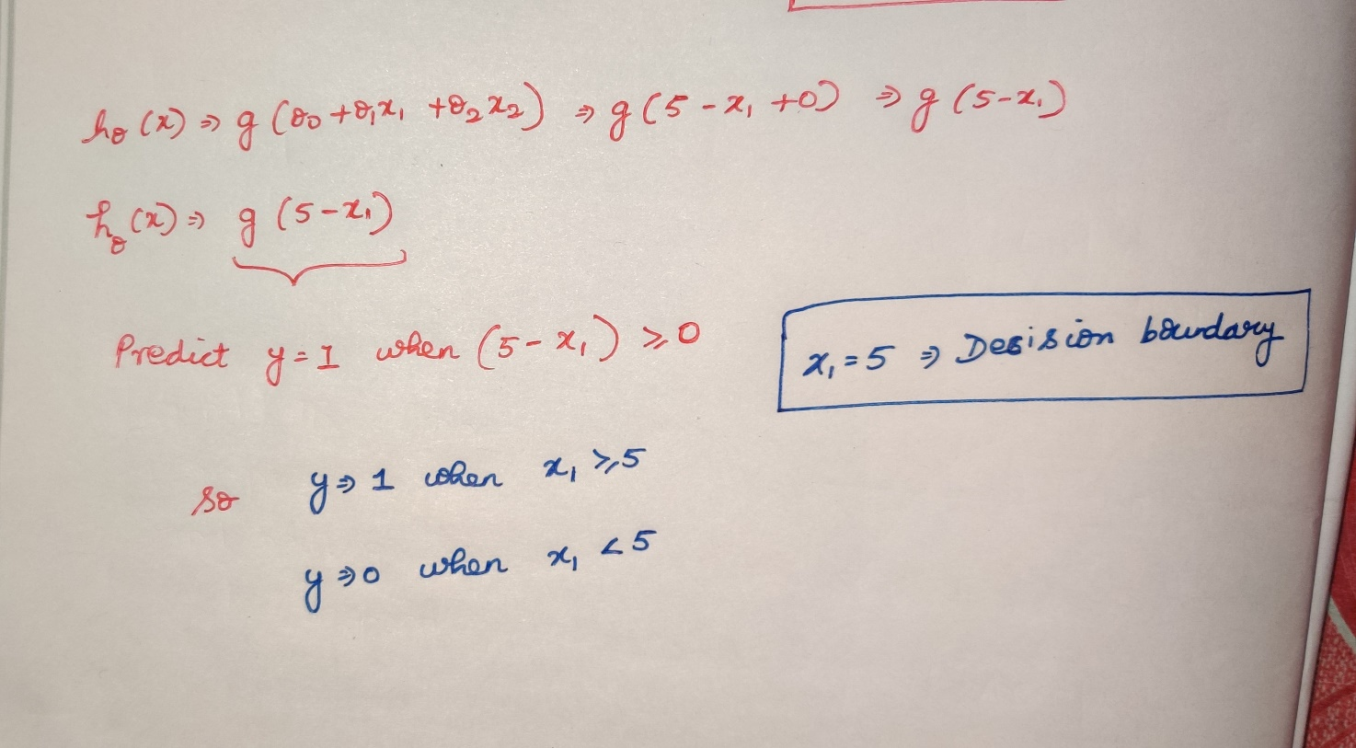

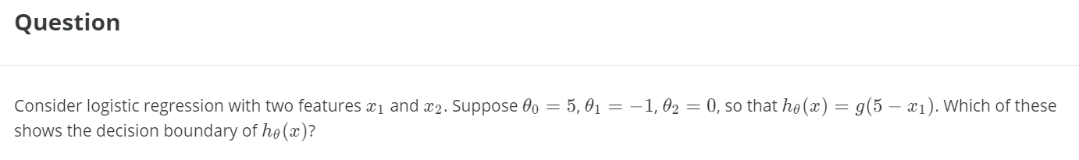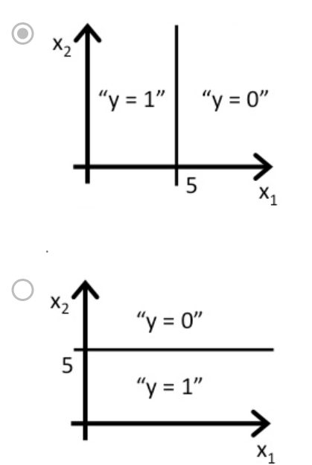 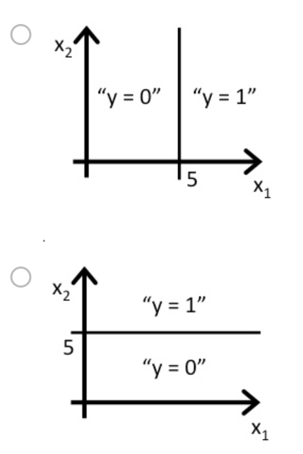

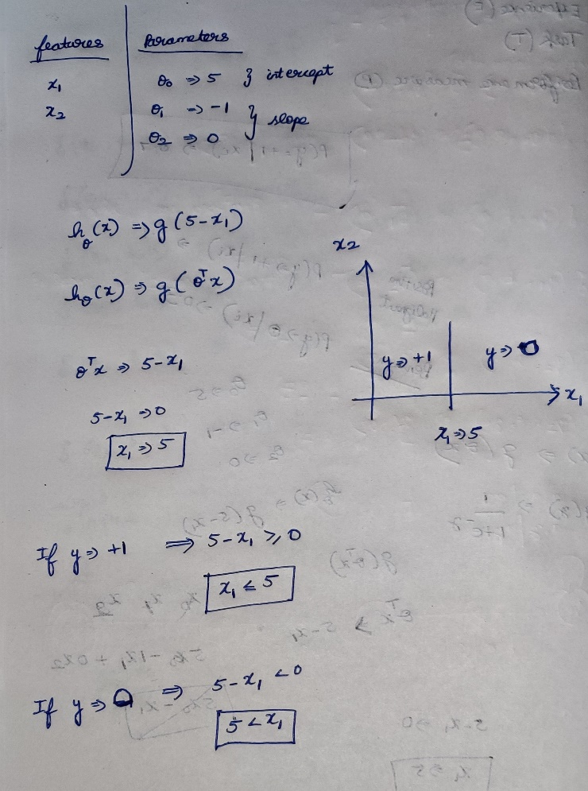

Decision boundary   
* Depends on the property and parameters of the hypothesis.  
* Depends Not on the property of the data-set.  
* Data-set is used to find only the parameters.

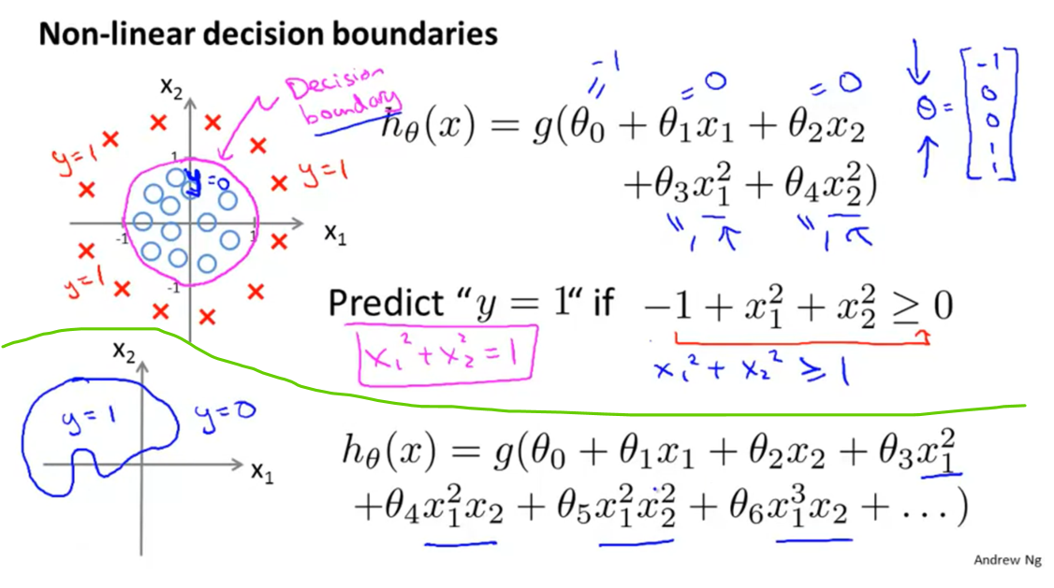

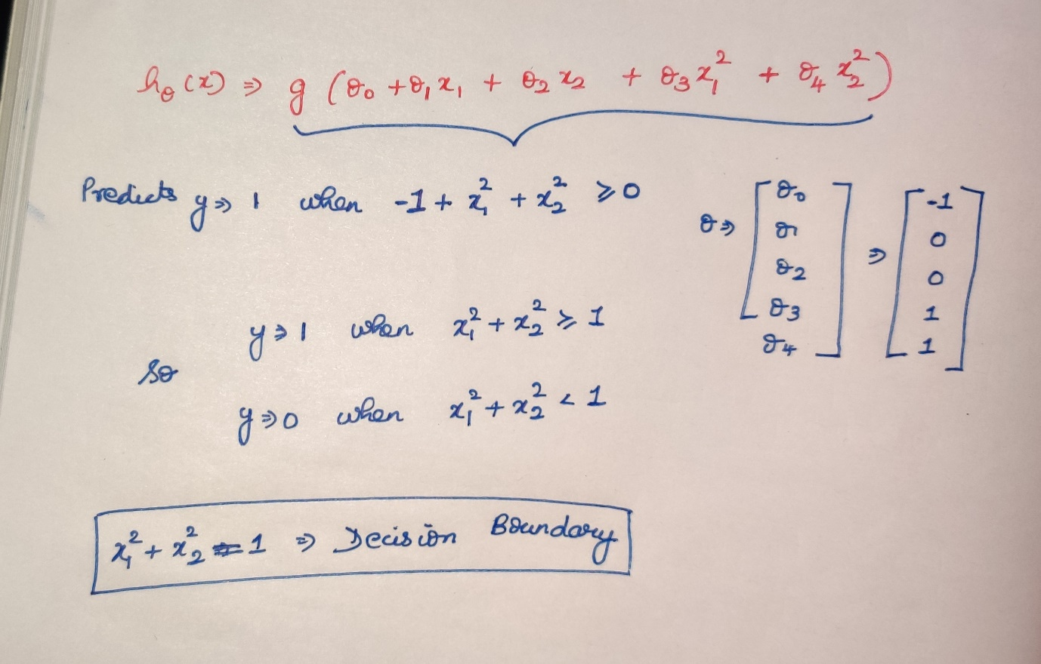

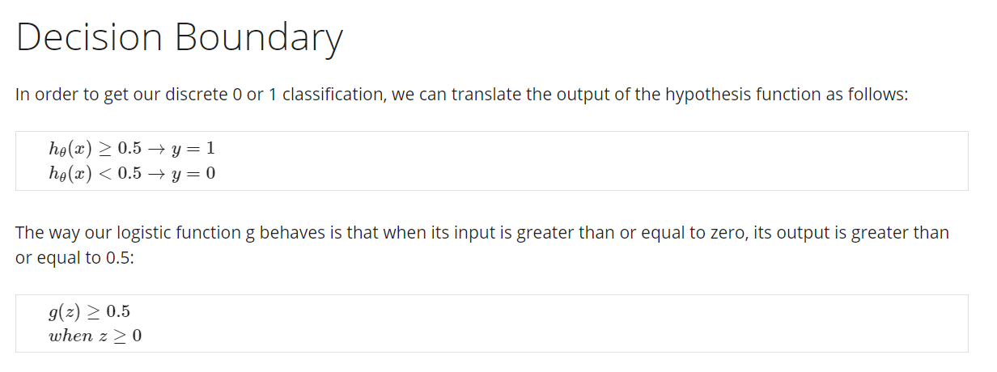

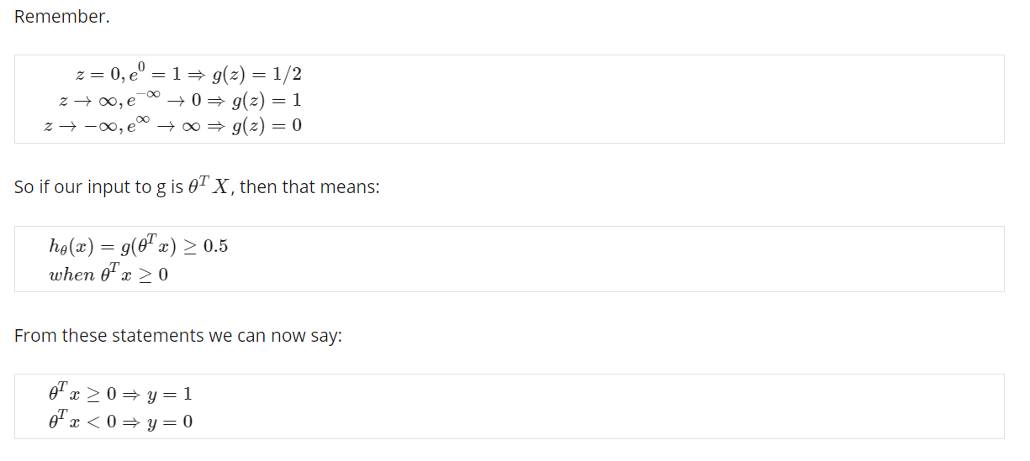

# **Logistic Regression Model**

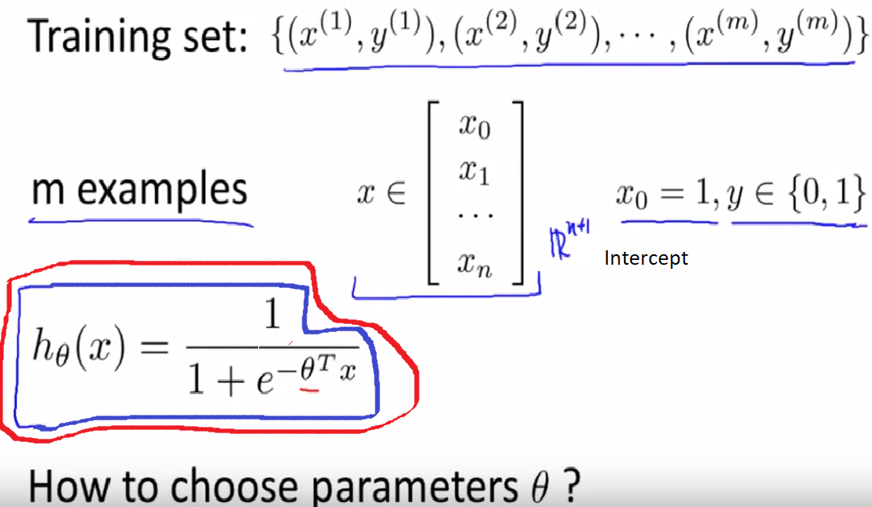

Given the data-set.  
How do we choose / how do we fit the parameter’s theta ??

## **Cost function**

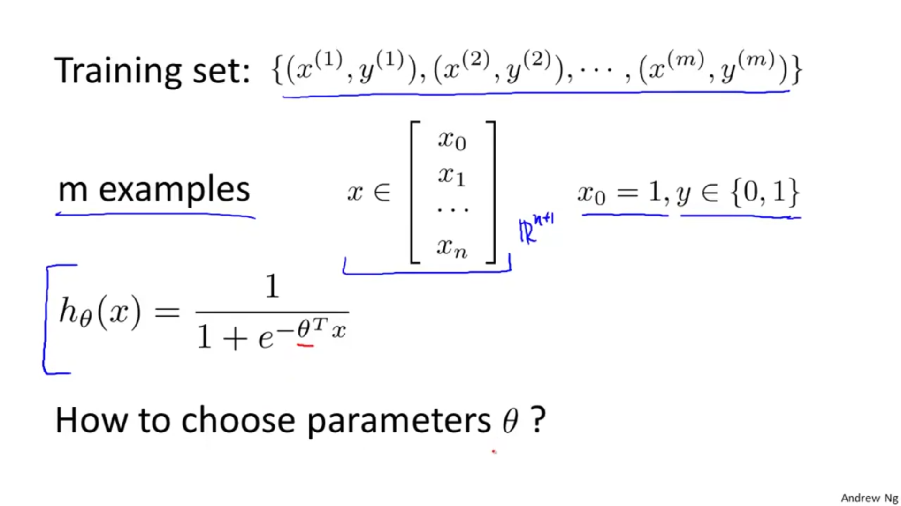Given the training set and with the hypothesis how are we going to choose the parameter theta ??

### **What happens if we use linear regression’s cost function for logistic regression also ????**

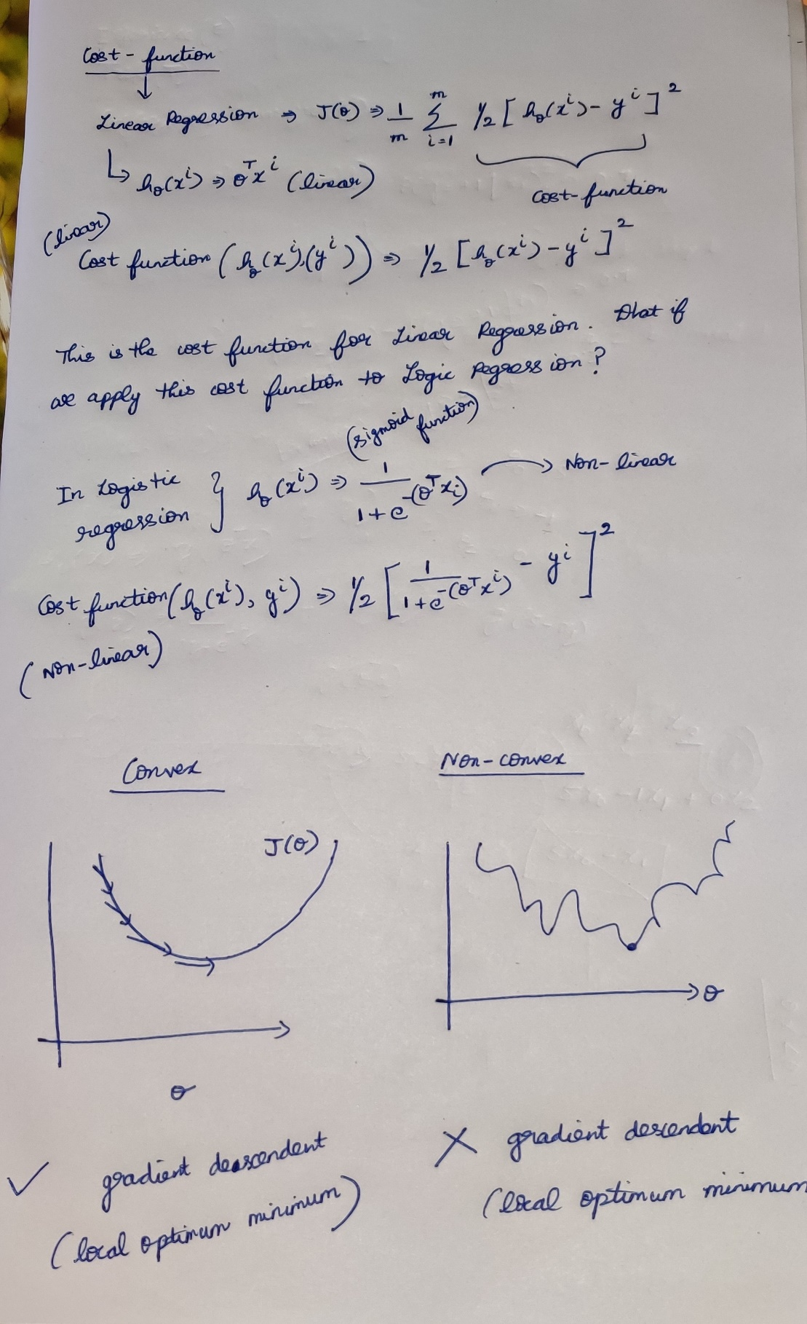

* If I run gradient descendent on a convex function, it is very clear that the algorithm will approach to the local minimum point.
* If I run gradient descendent on a non-convex function, there is no way to reach to approach to the local minimum point.
* So the cost function used for regression cannot be applied to the logistic regression.

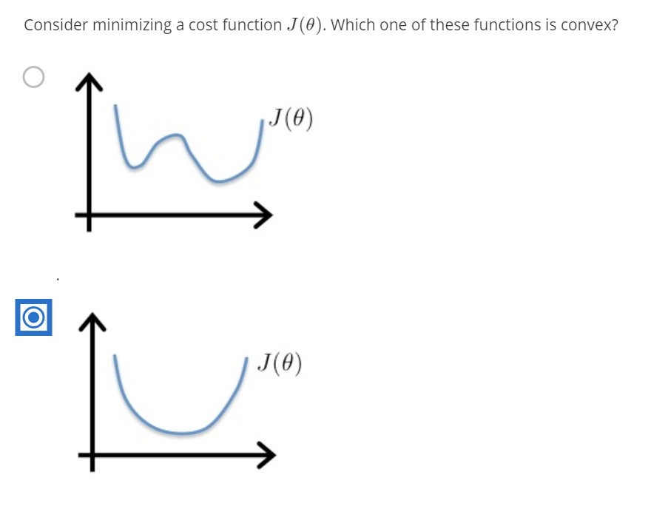

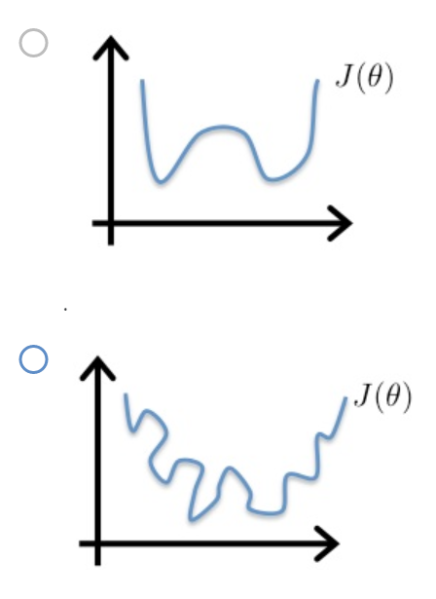

### **Logarithmic plots**

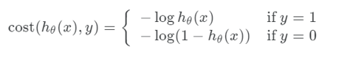

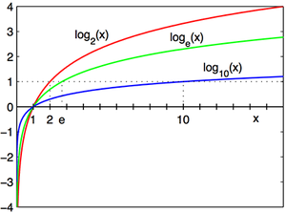

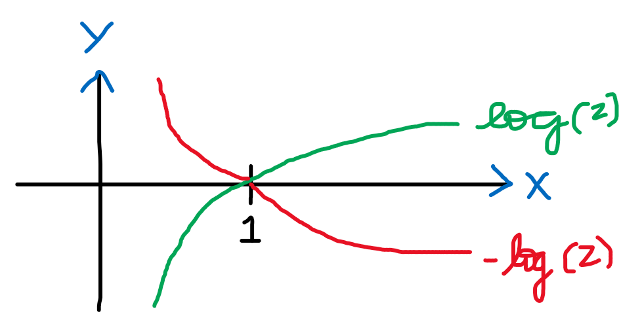  
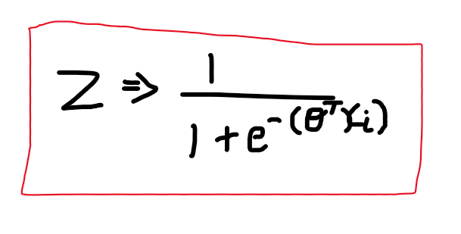

If y=+1

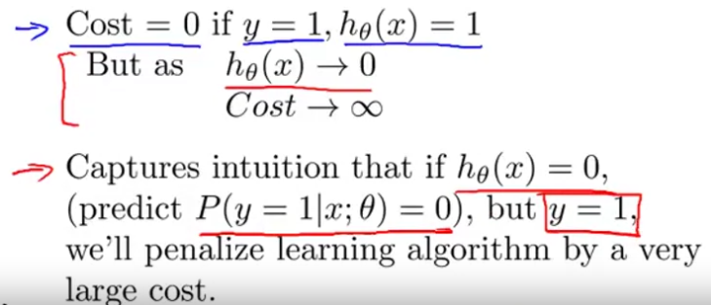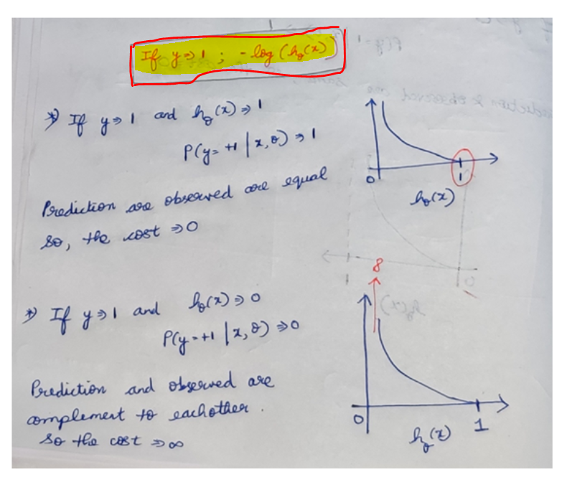

If y=0  
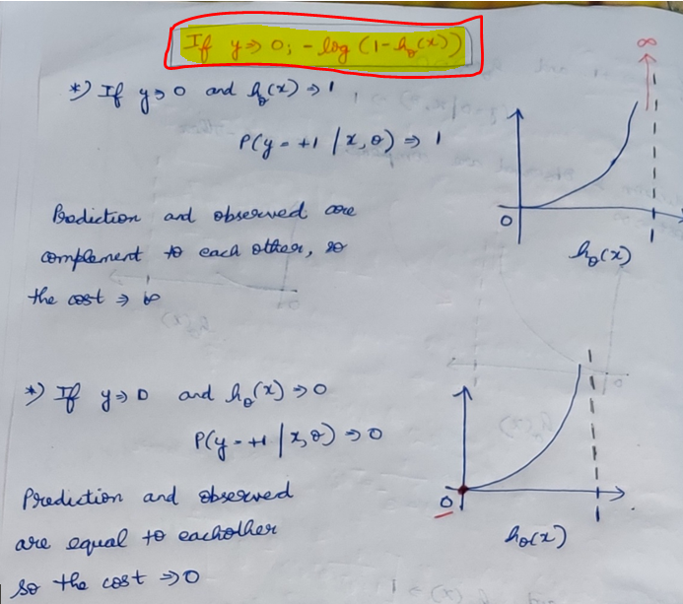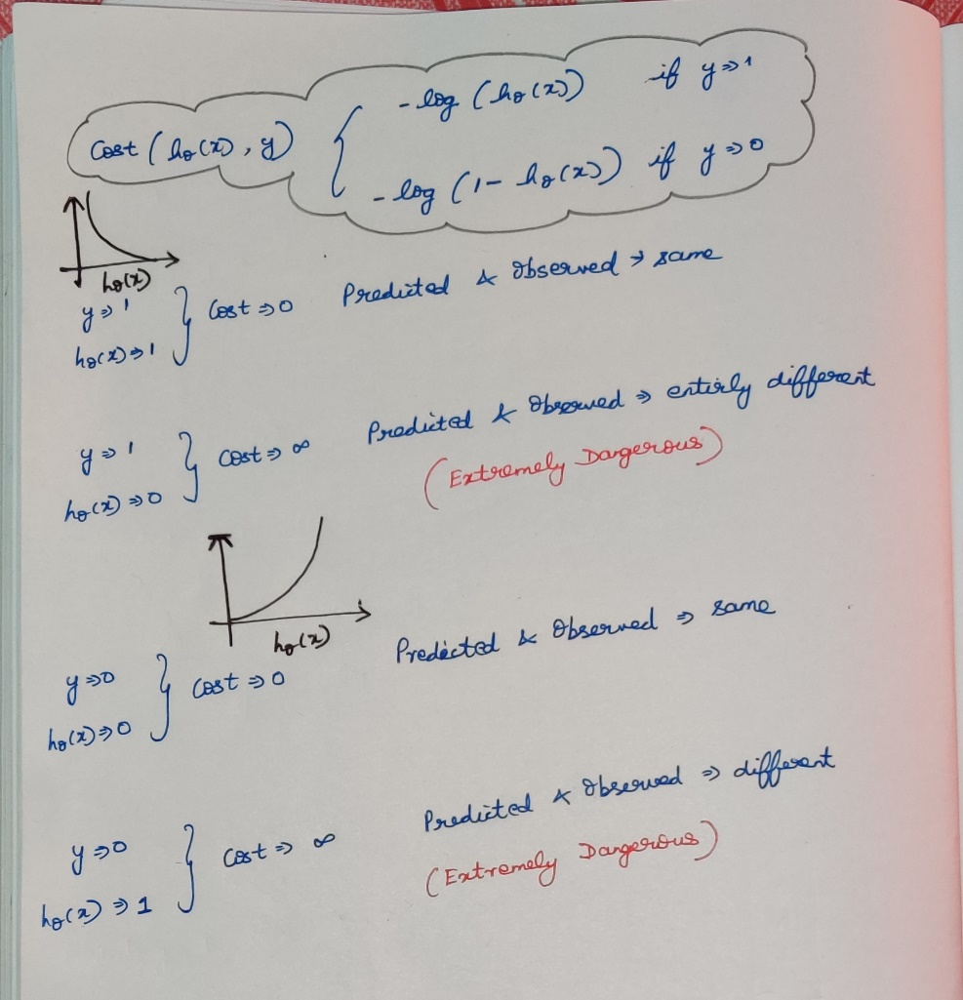

### **Quiz**

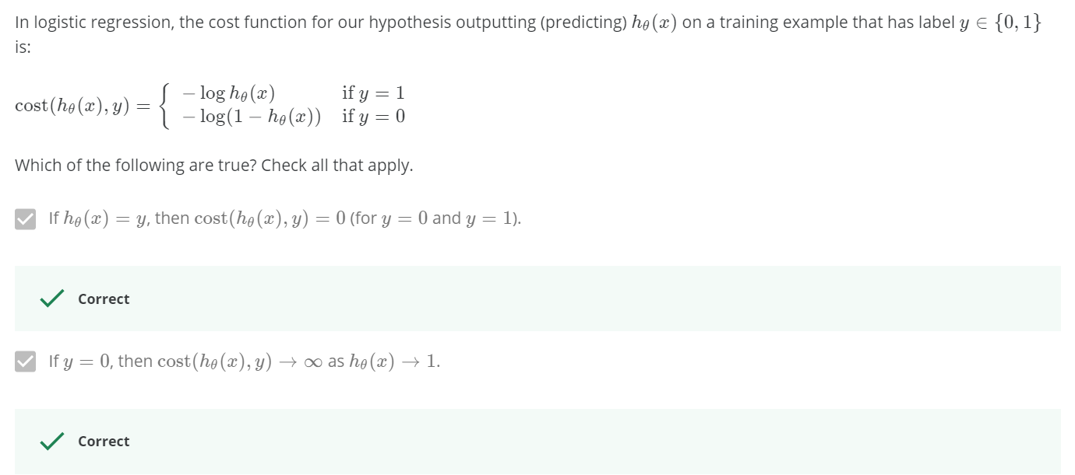  
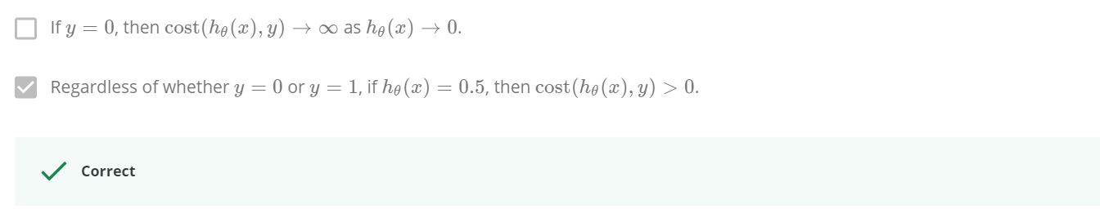

### **Reading**

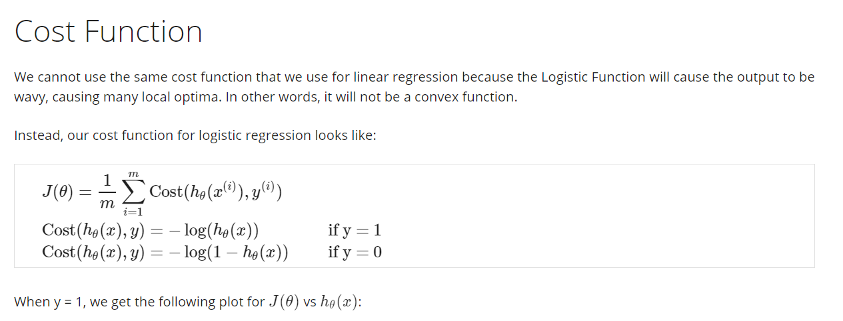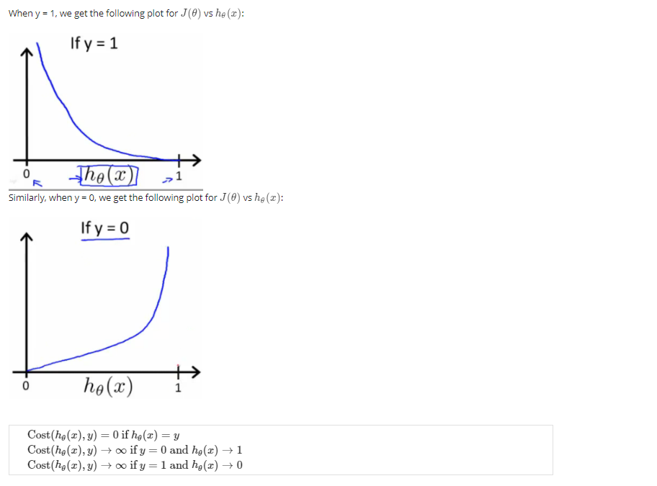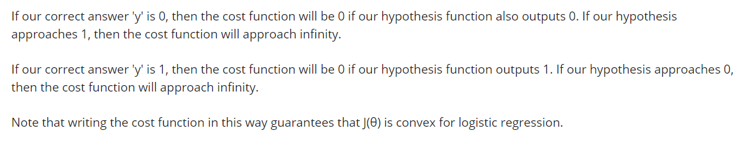

## **Simplified Cost function and Gradient Descent**

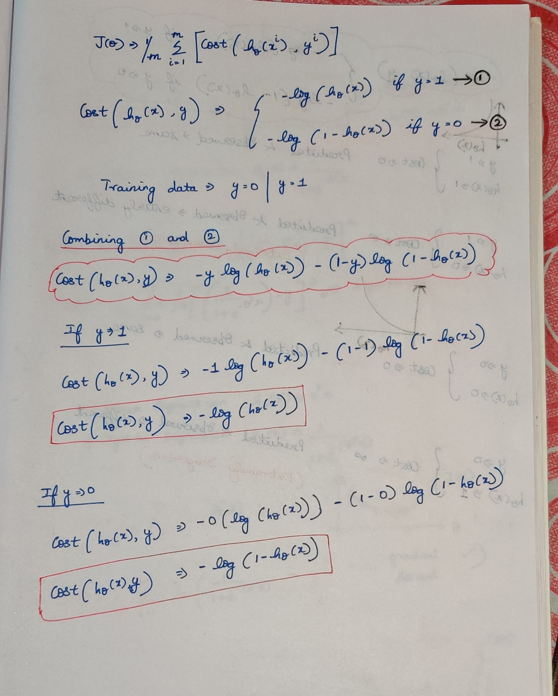

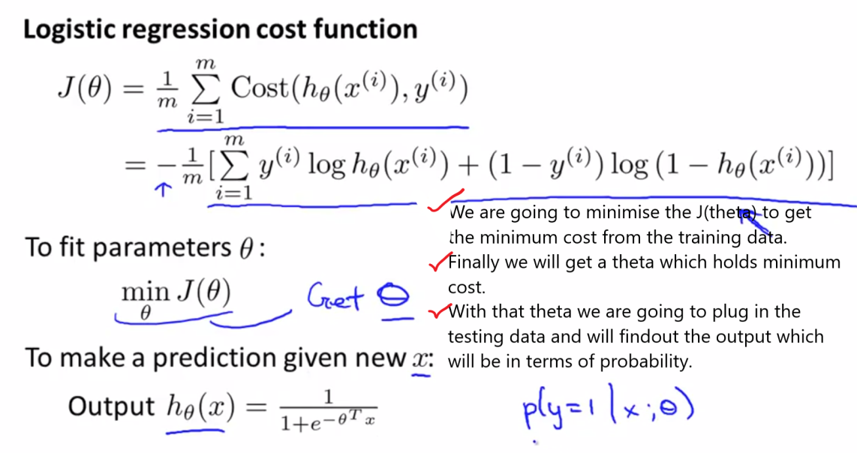

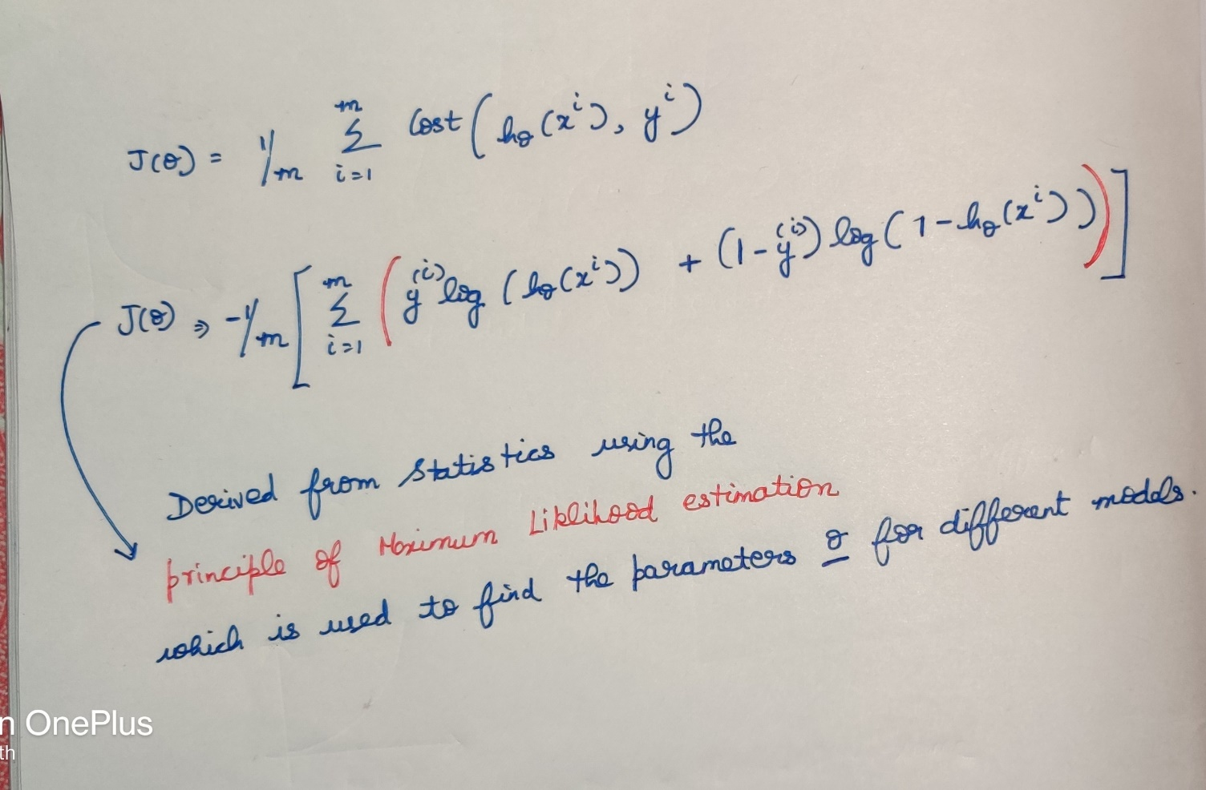

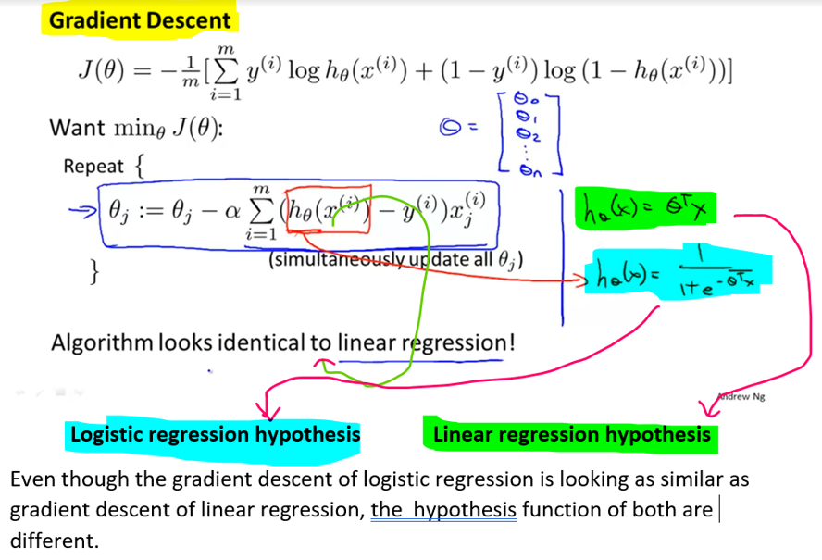

### **Quiz**

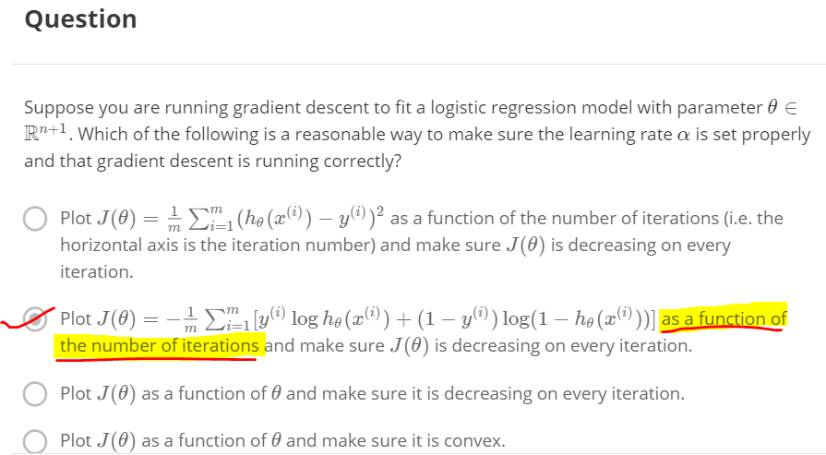

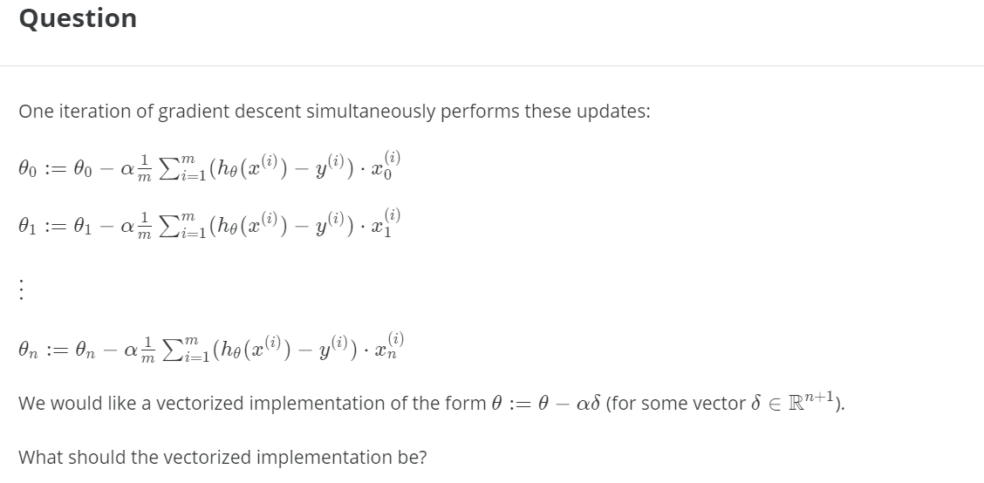  
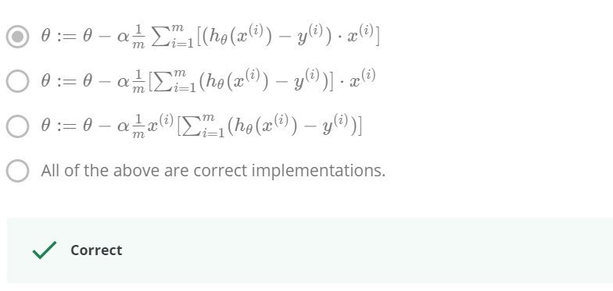

### **Reading**

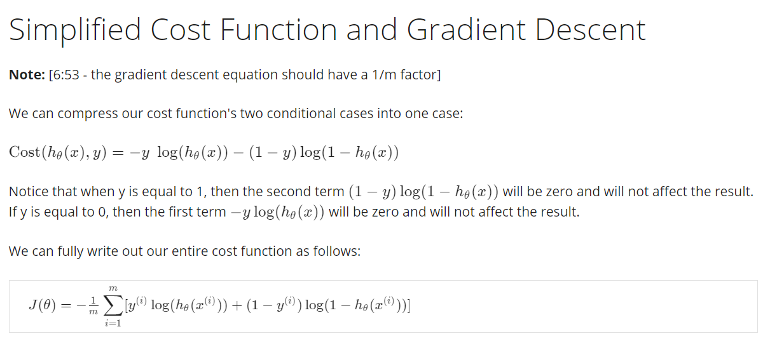

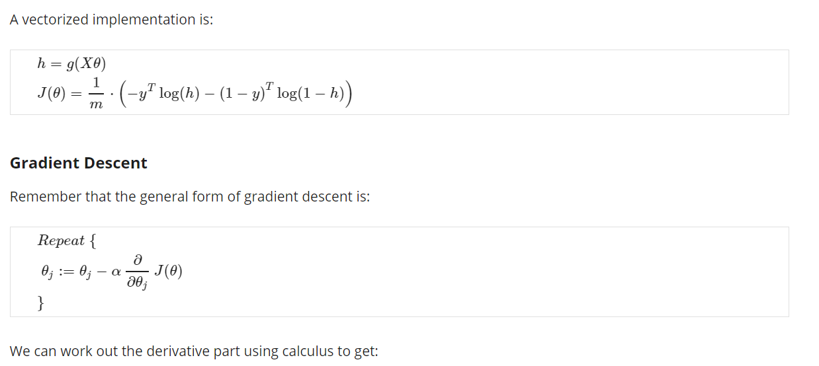

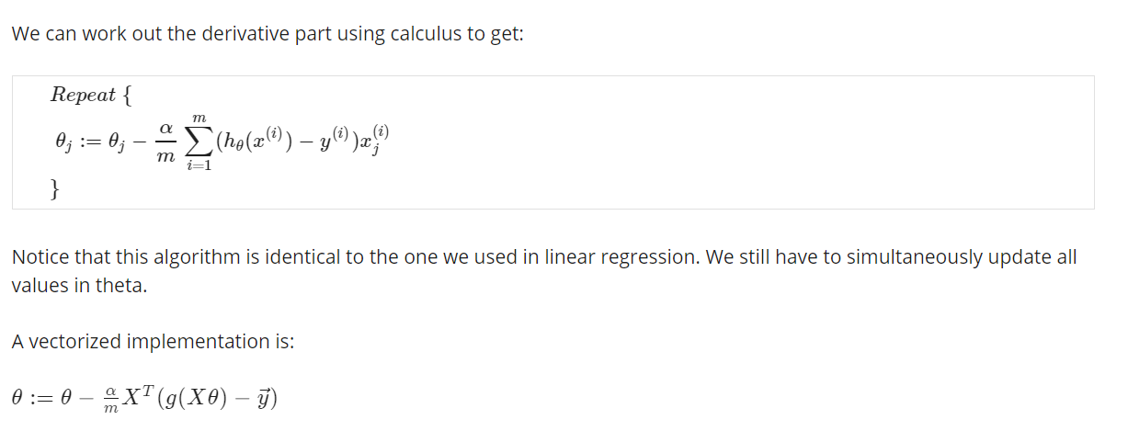

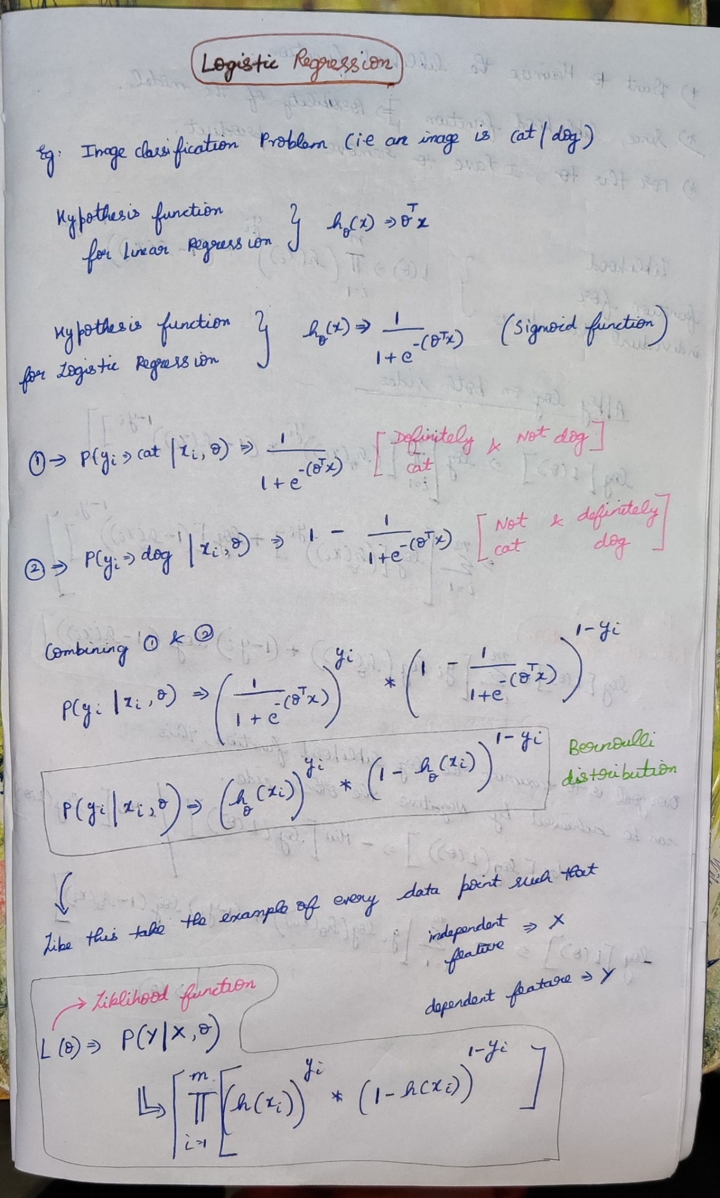



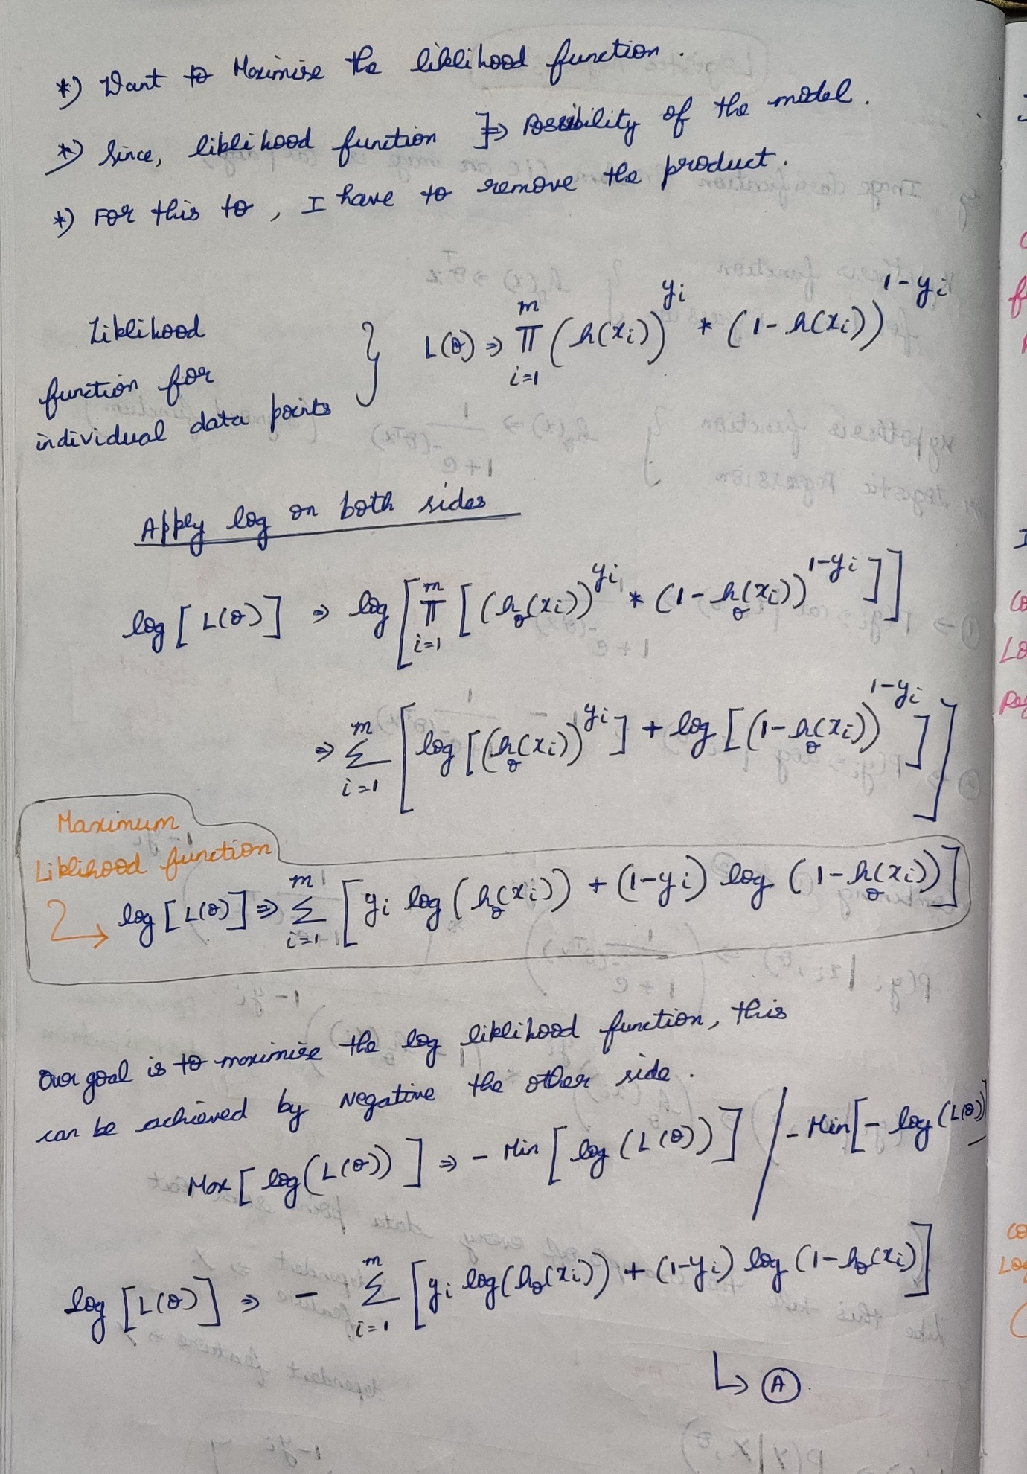

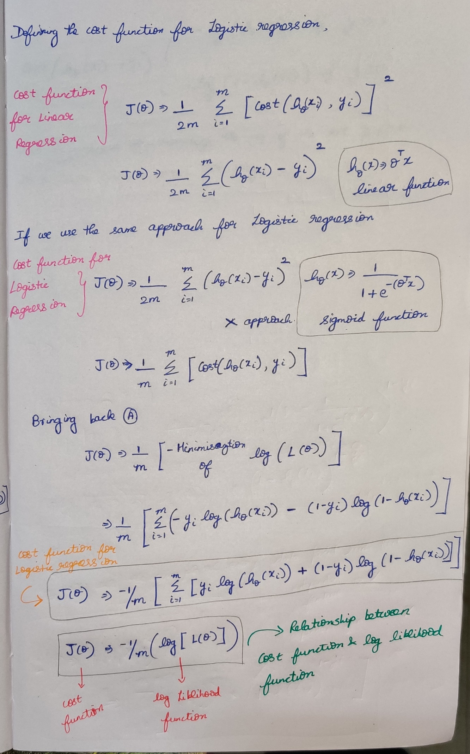

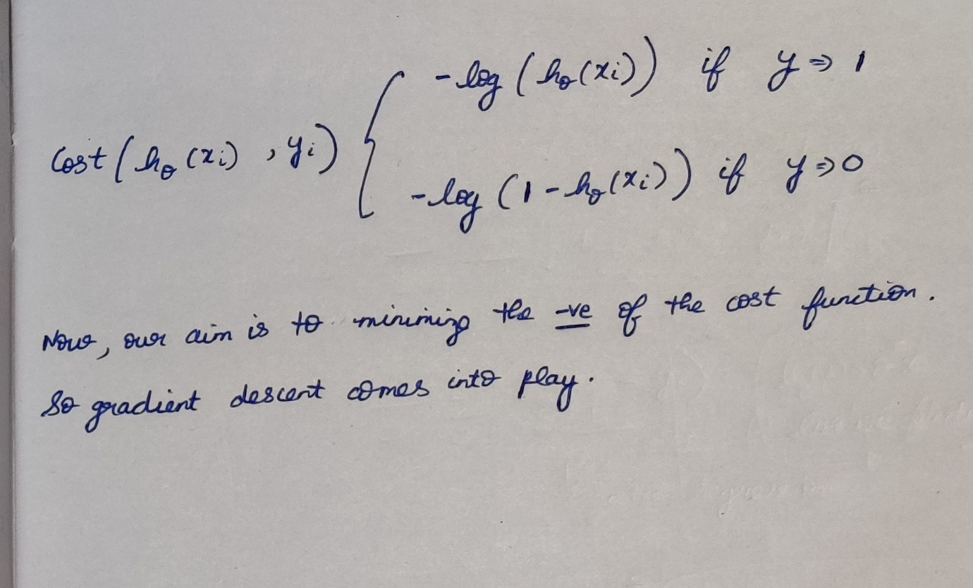

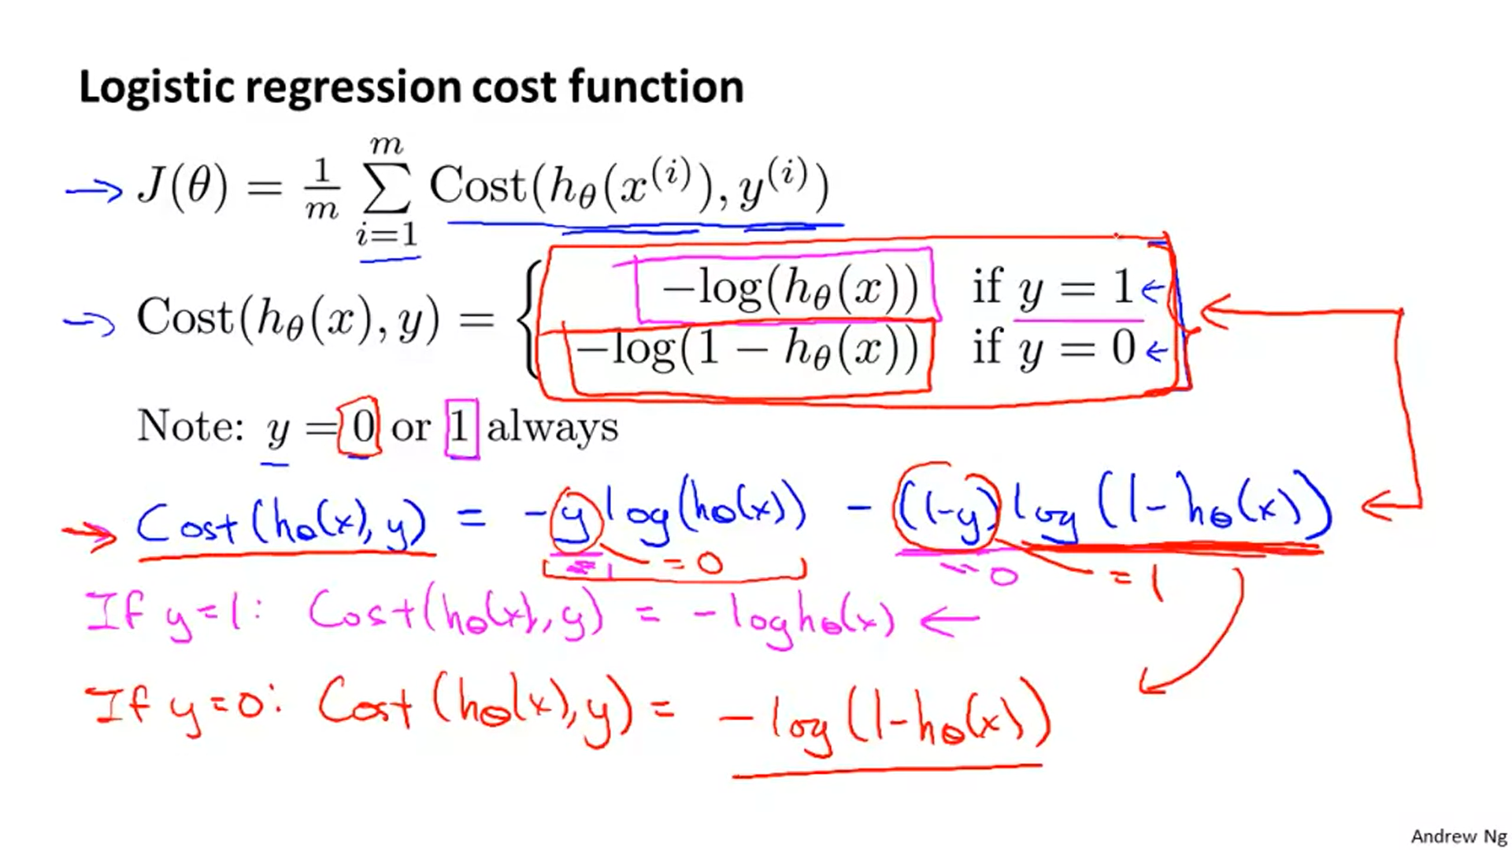



**Advanced Optimization for Logistic Regression**

This advancement is done in-order to make the logistic regression run faster when it is used in gradient descent.

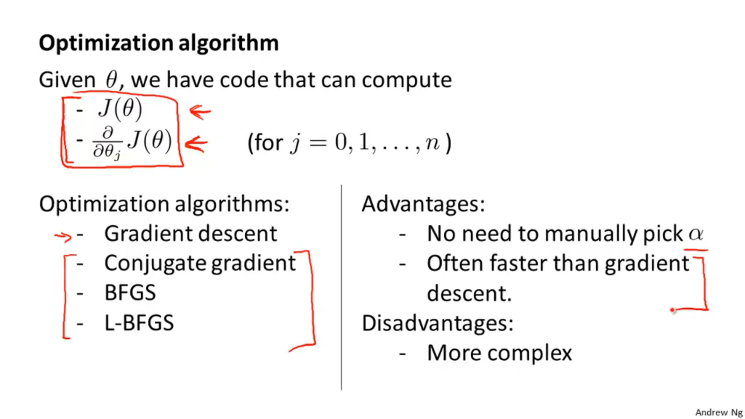



In octave the indices starts from 1 rather than 0.

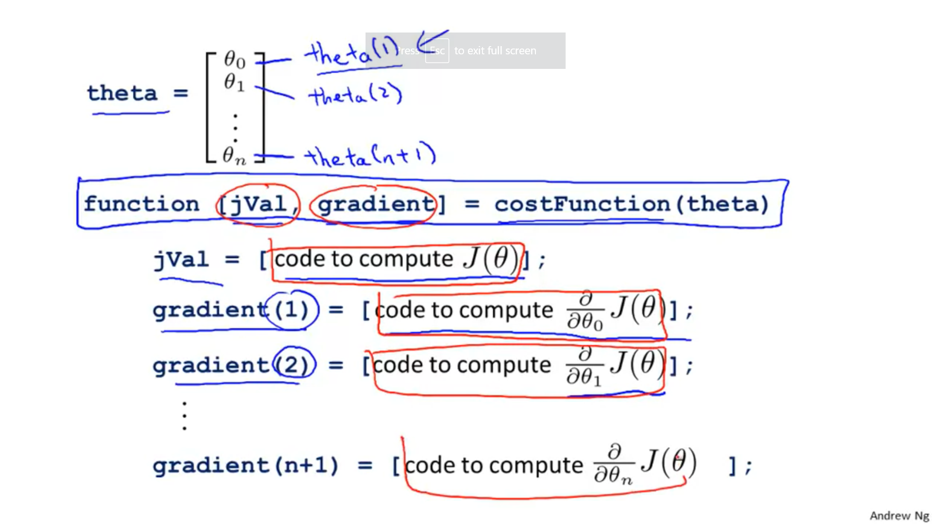

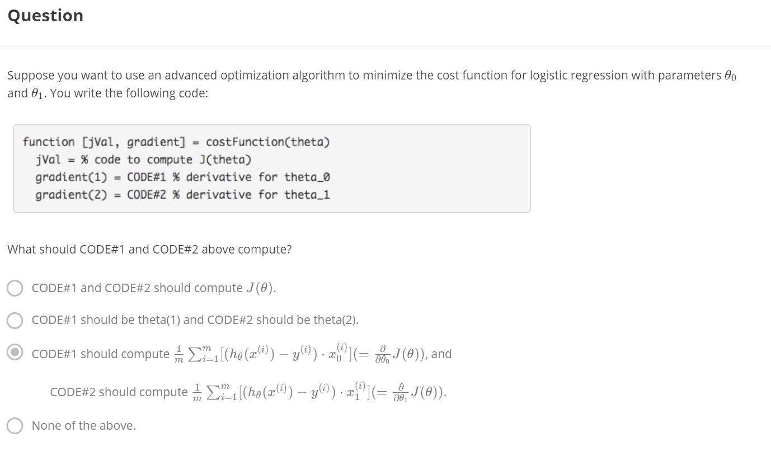

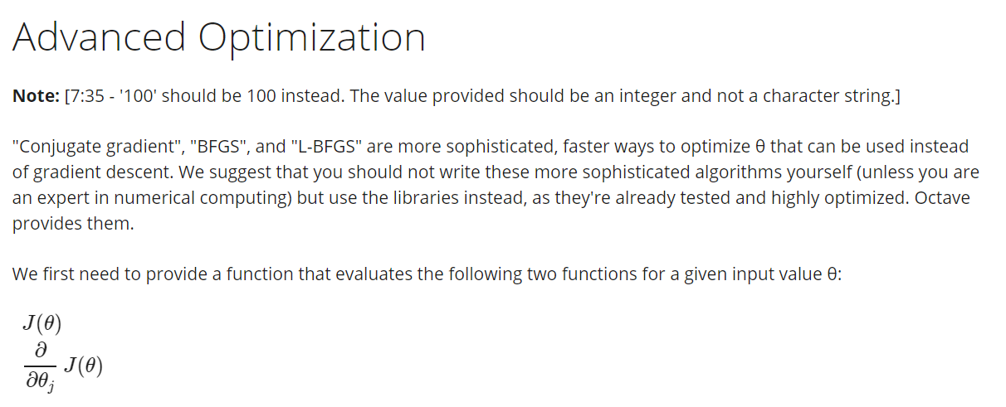

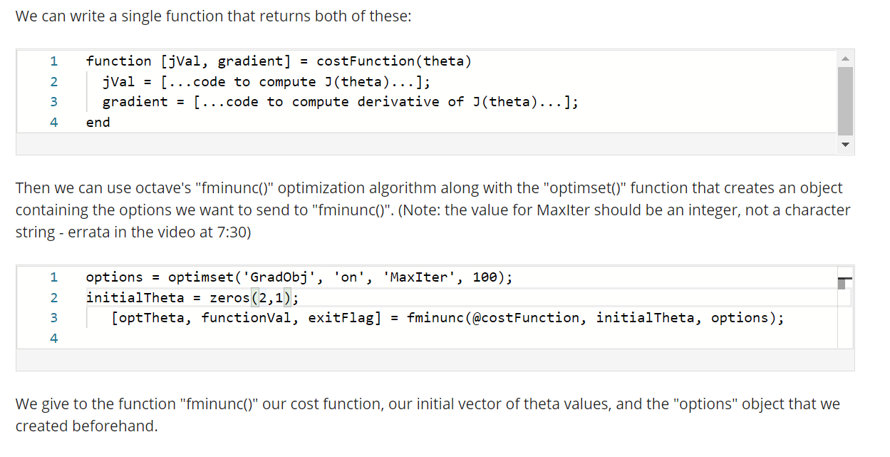

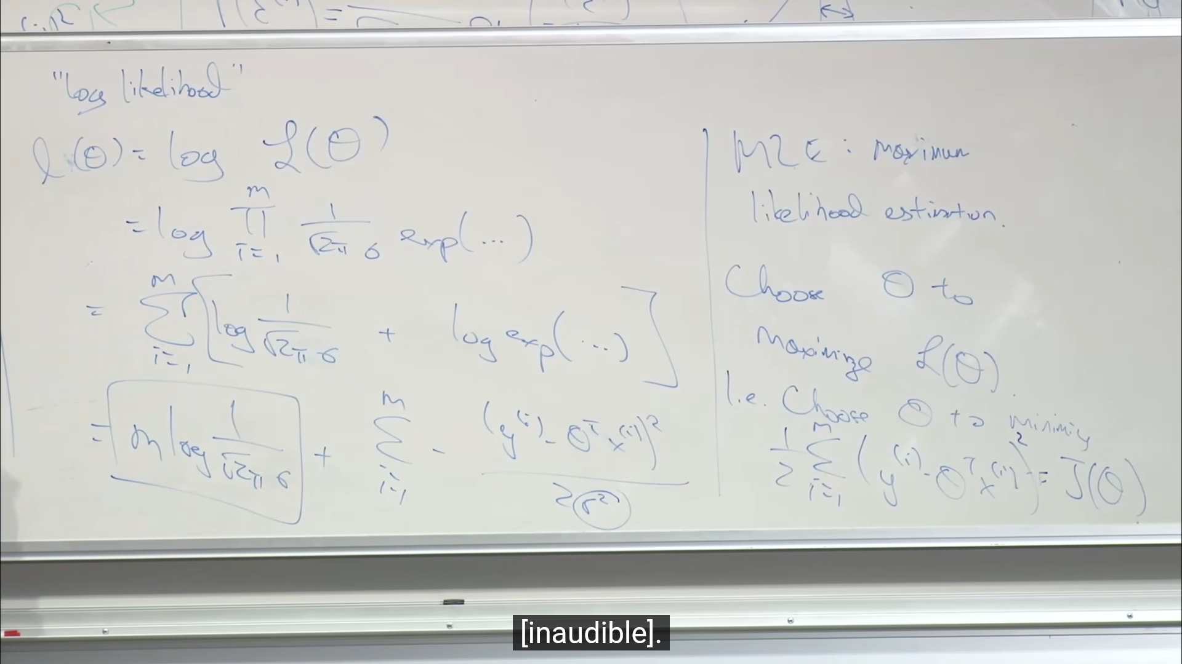

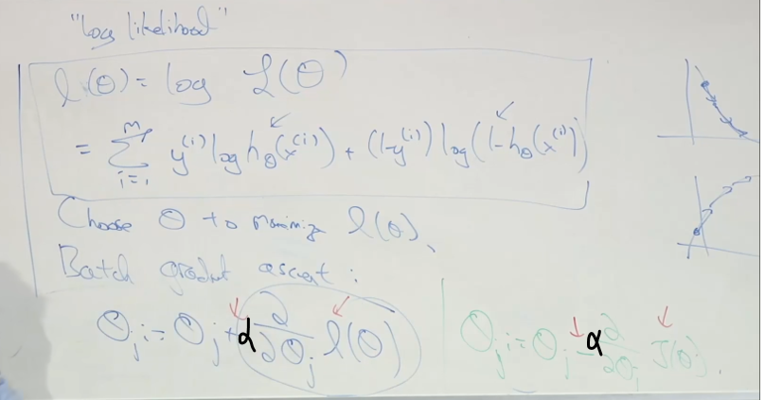

**Newton’s method**

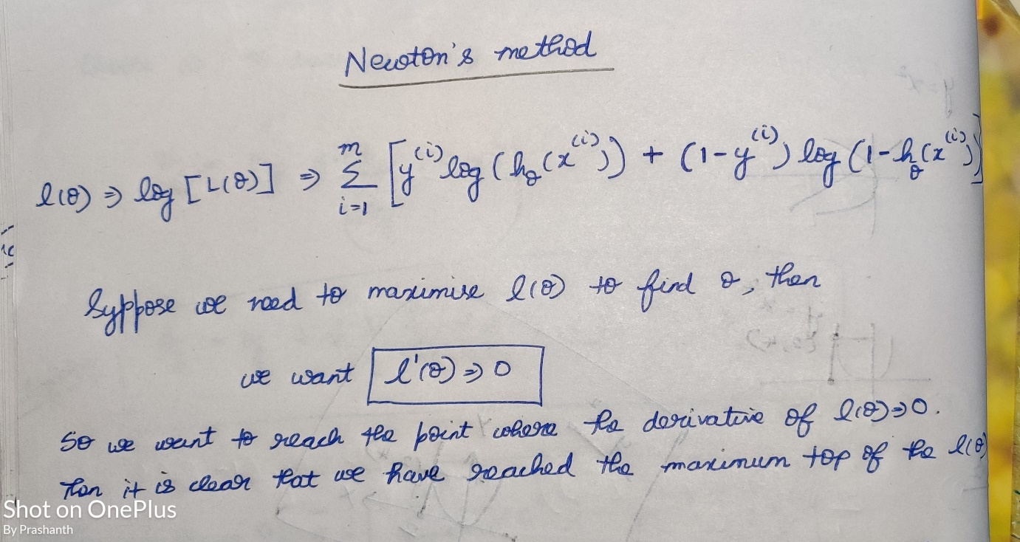

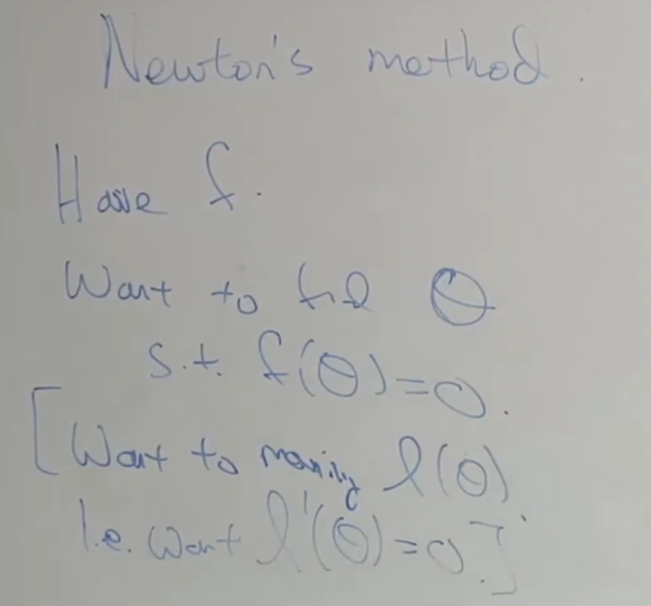

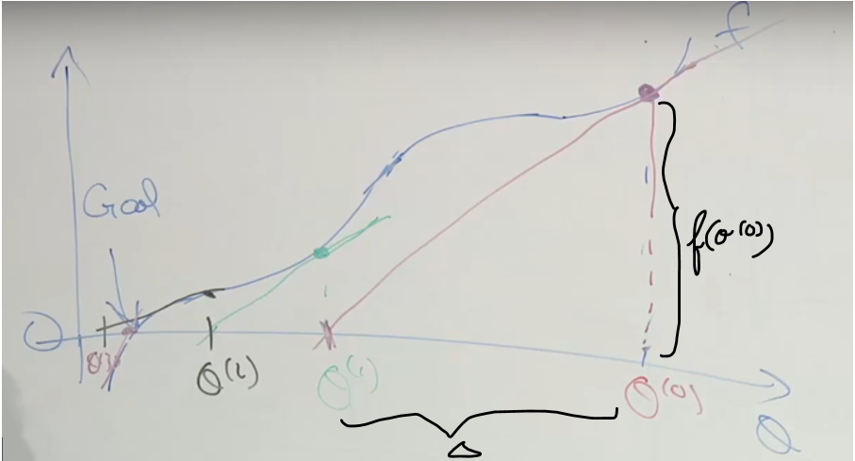

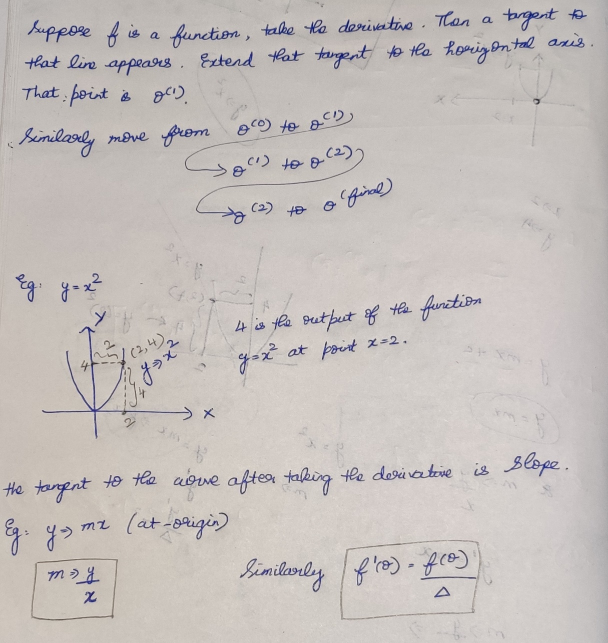

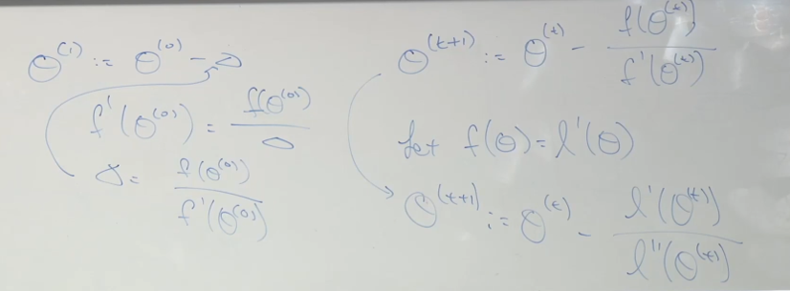

When is a real number



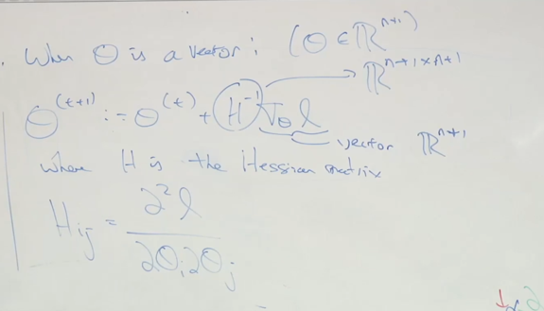

Use gradient Descent 🡪>50 features  
Use Newton Method 🡪 <50 features (Taking inverse is too complicated)

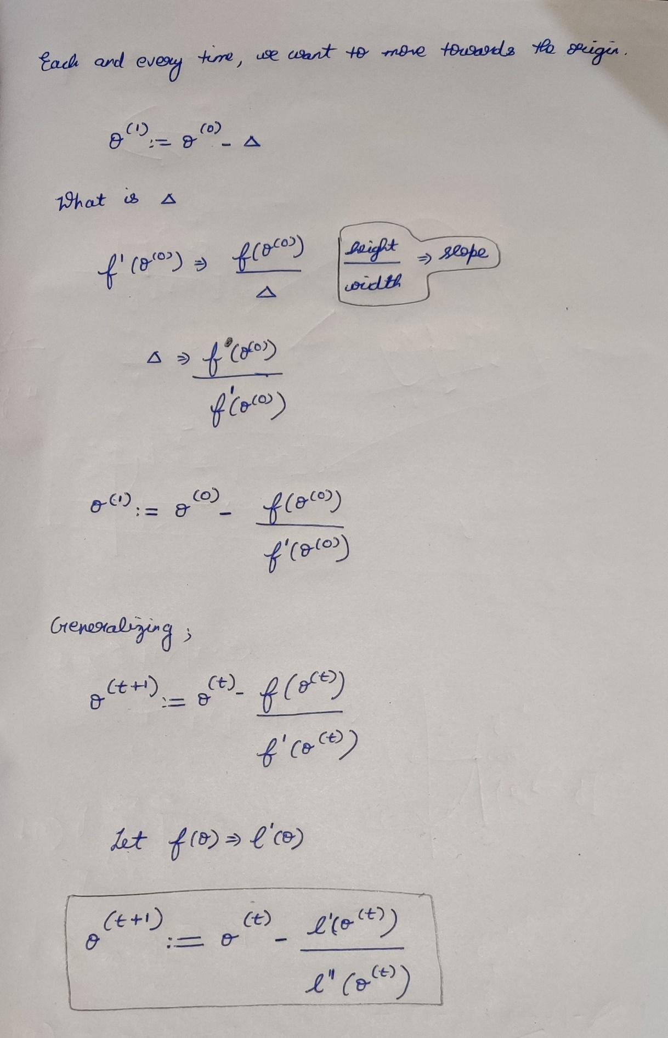

References :

Cost function in Logistic Regression  
<https://medium.com/analytics-vidhya/cost-function-in-logistic-regression-95cd5289a42>

Introduction of Logistic Regression <https://towardsdatascience.com/introduction-to-logistic-regression-66248243c148>

[Day 4 — Logistic Regression. Today we’ll focus on a simple… | by Tzu-Chi Lin | 30 days of Machine Learning | Medium](https://medium.com/30-days-of-machine-learning/day-4-logistic-regression-df9a7a2220cd)

Logistic Regression with Newton’s method Implementation  
<http://openclassroom.stanford.edu/MainFolder/DocumentPage.php?course=MachineLearning&doc=exercises/ex4/ex4.html>

<https://thelaziestprogrammer.com/sharrington/math-of-machine-learning/solving-logreg-newtons-method>